NAME:  **V.Venkatesh Batch-12 Course – AWS & DevOps Assessement - B12 Mobile No: 8074013862 Check below the tasks......**

**Task1: Launching an ec2 in AWS using through ssh , Powershell , Gitbash**

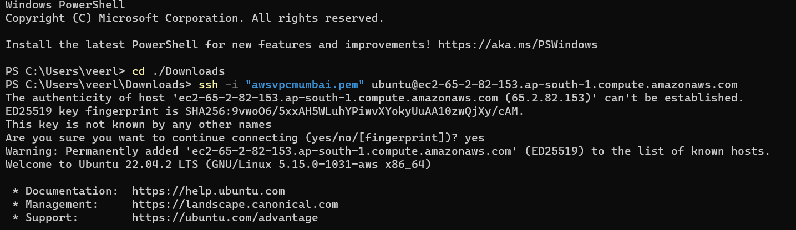

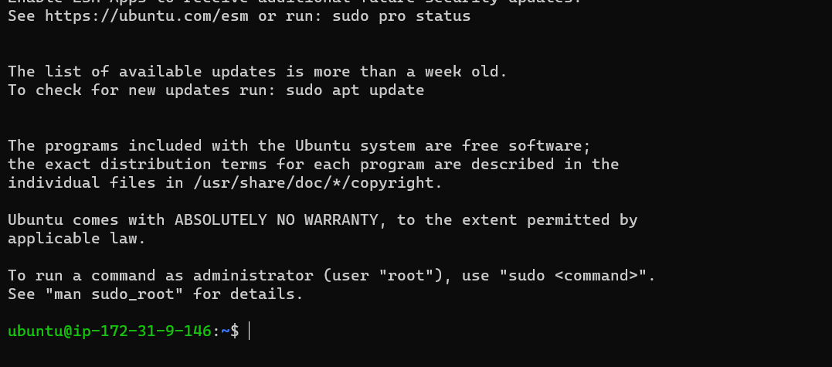

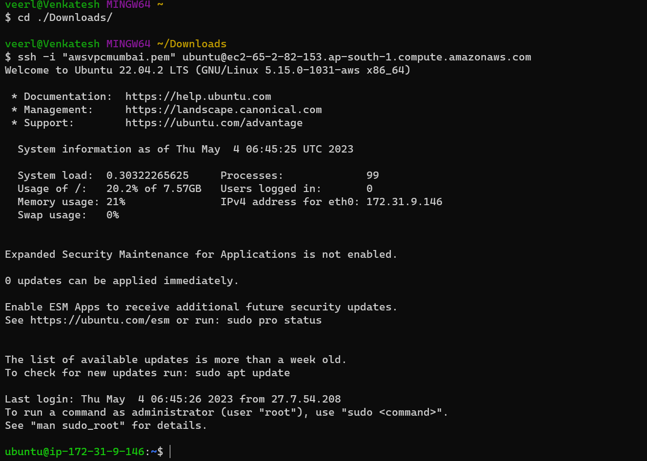

**TASK2: USING Choco installing necessary softwares**

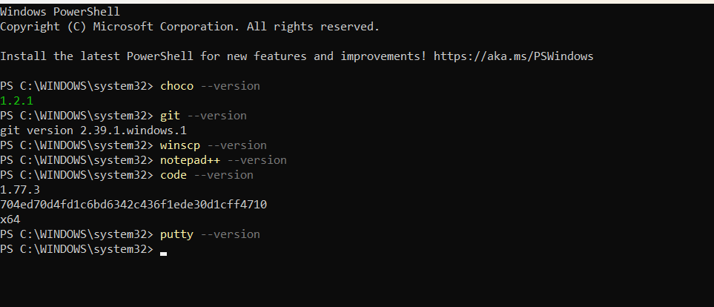

**Task 3: Security group aws , 22,80,443**

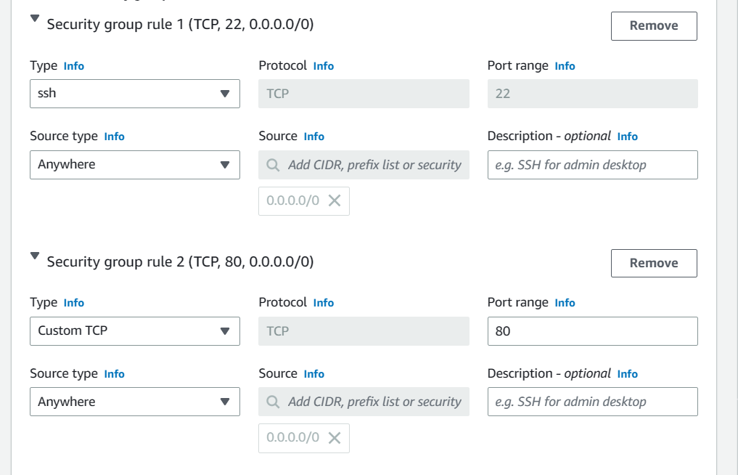

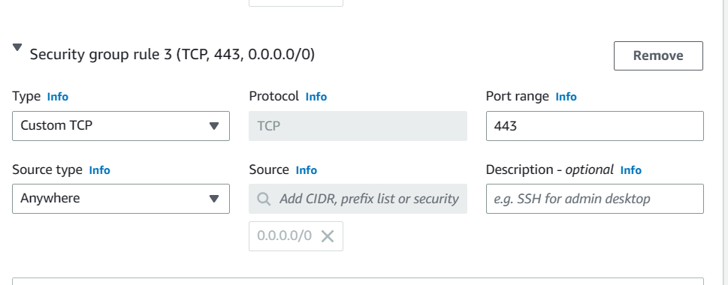

**Task 4 : Create a Keypair in AWS.**

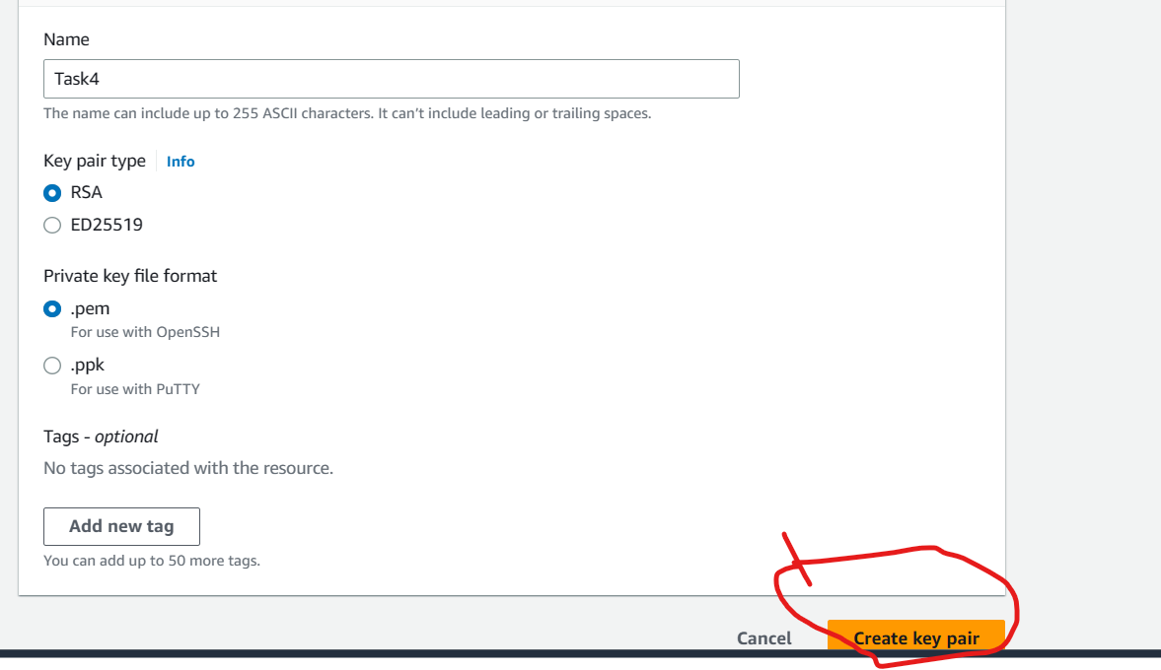

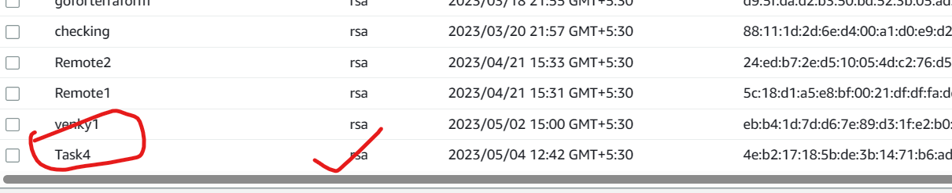

**Task 5 : Creating Add user/useradd/deleteuser/deletegroup/removeuserfrom group**

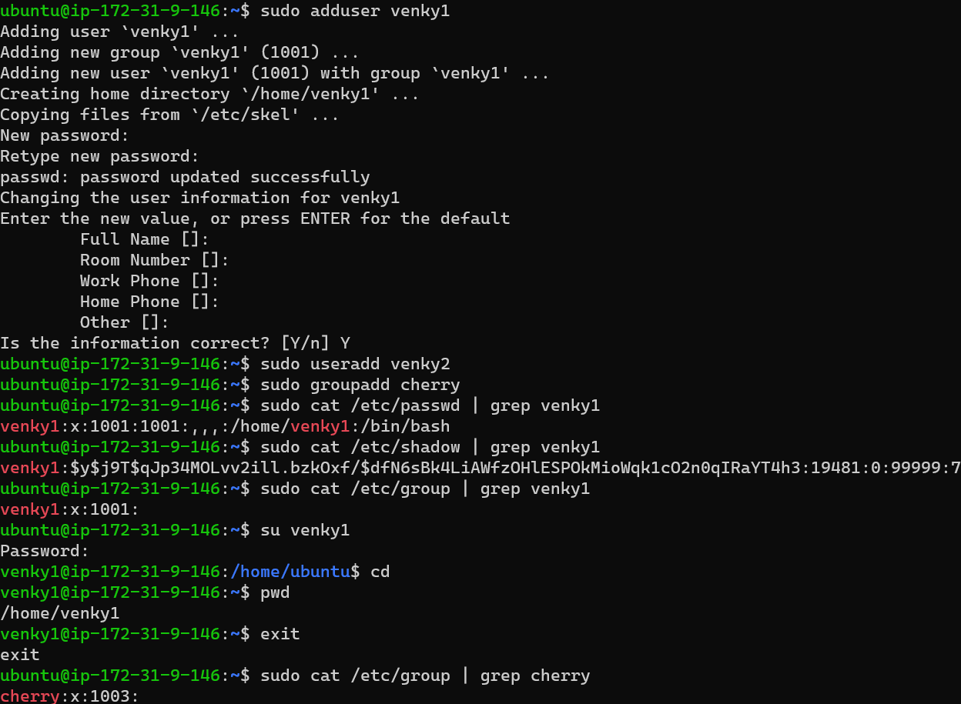

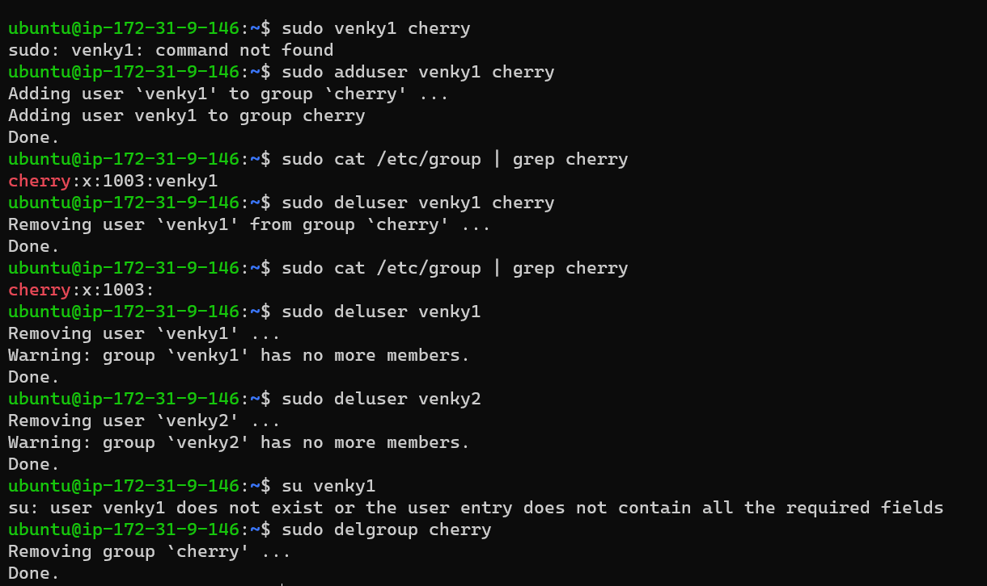

**Task 6 : Find the location of Users,Passwords,Groups**

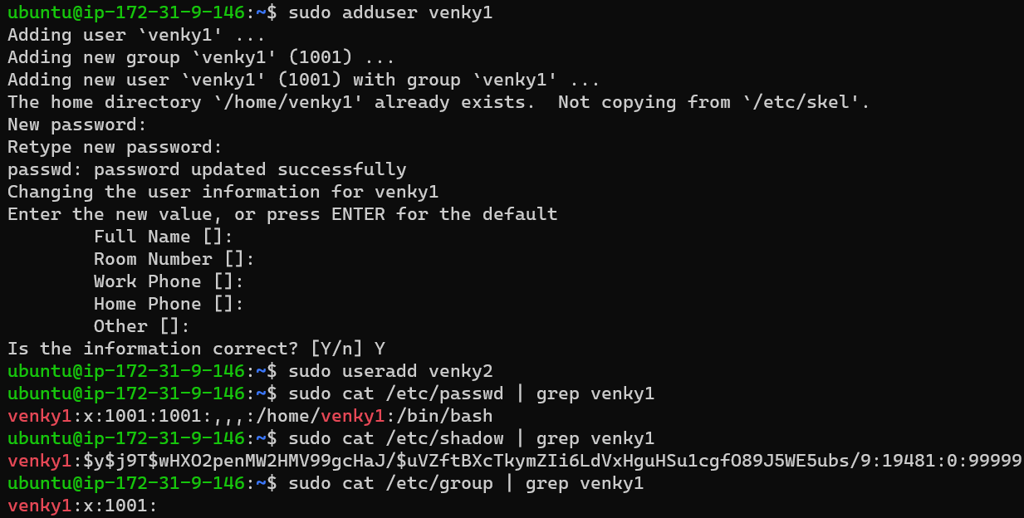

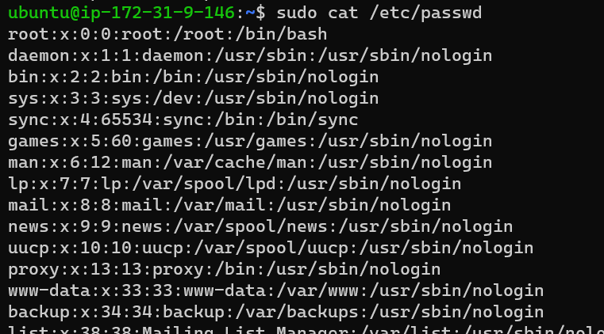

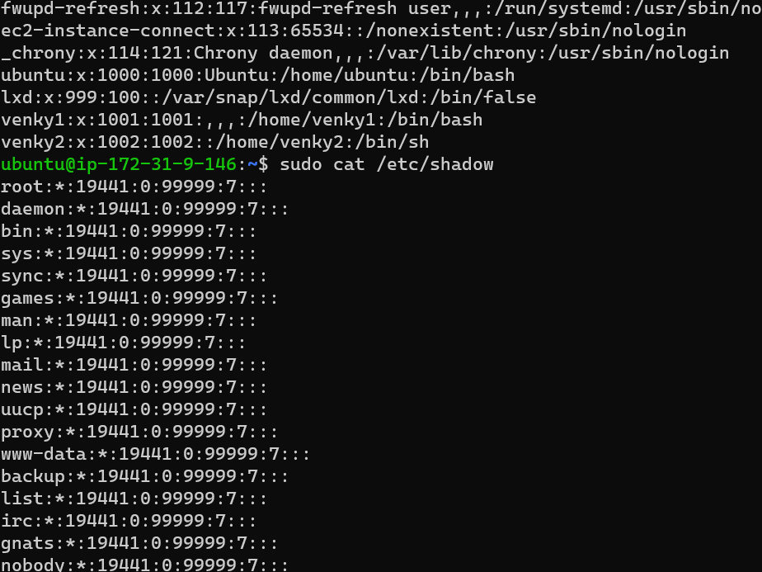

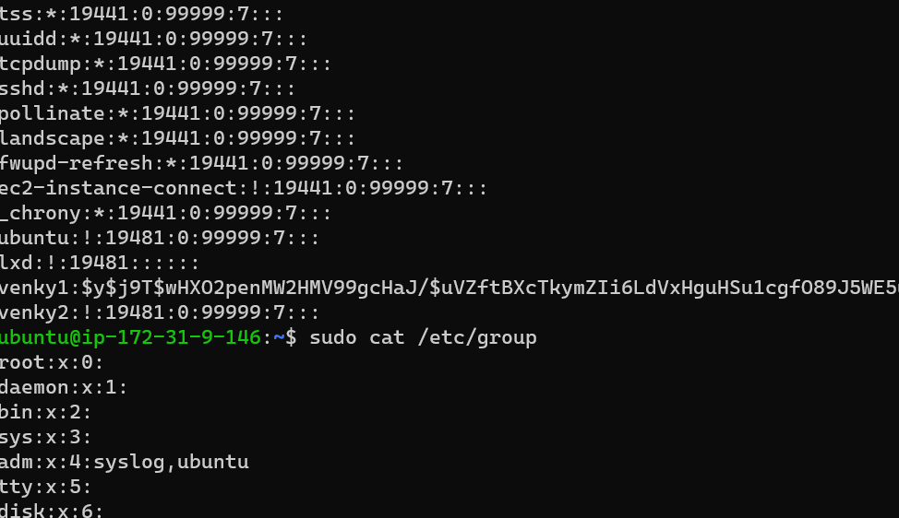

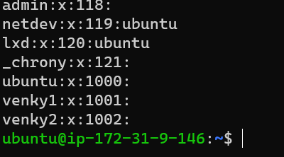

**Task 7 : sftp upload files in remote repository**

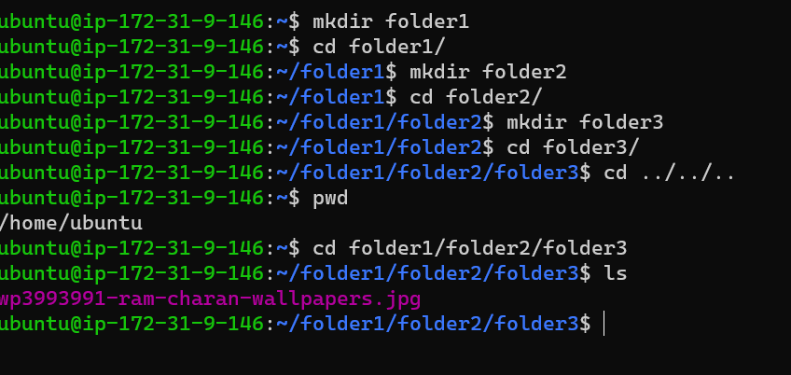

Login sftp connecting to machine

Put “image name” folder1/folder2/folder3

Upload successfully

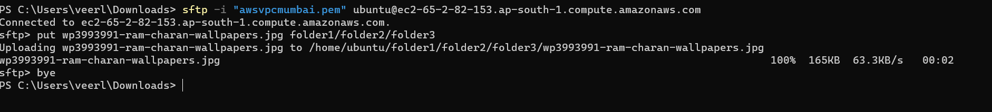

**Task 8 : Hand-on file permissions and Change Ownerships**

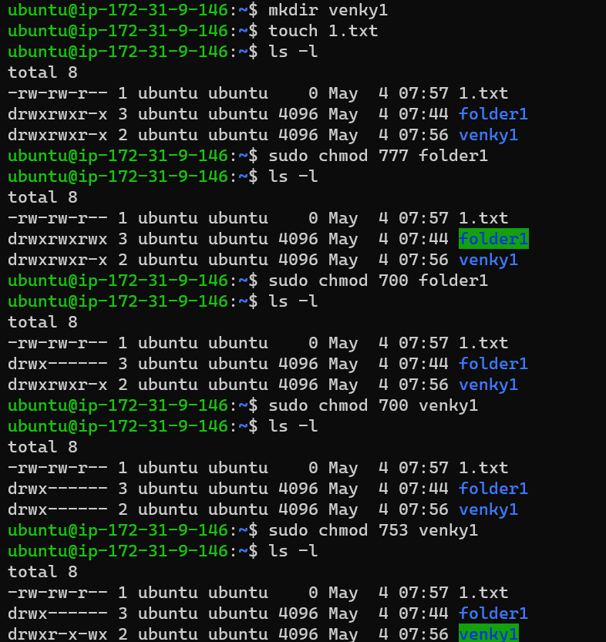

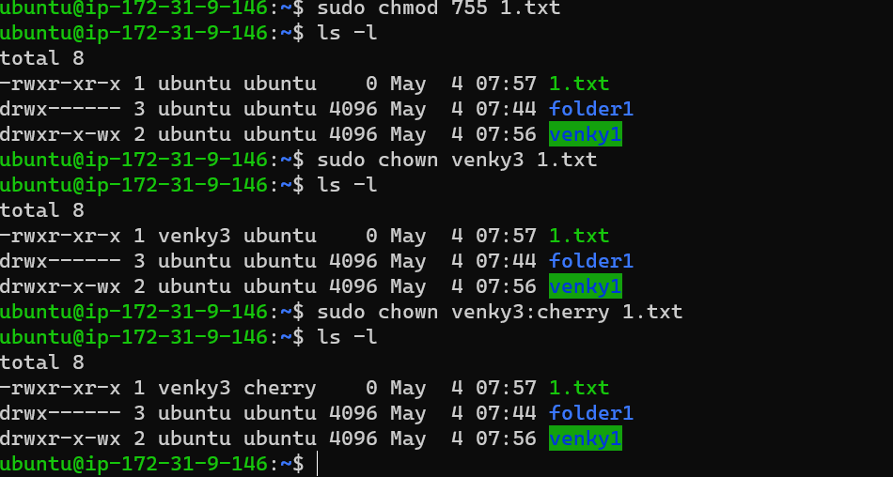

**Task 9 : Import key pair on AWS**

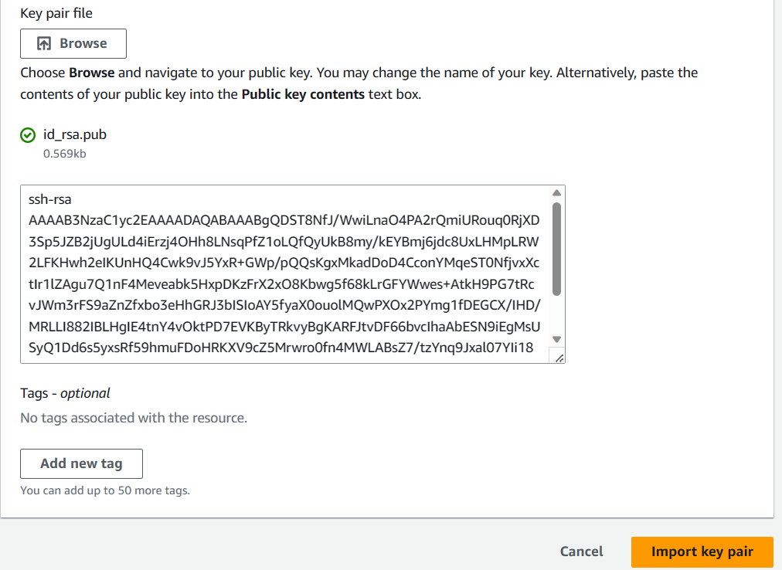

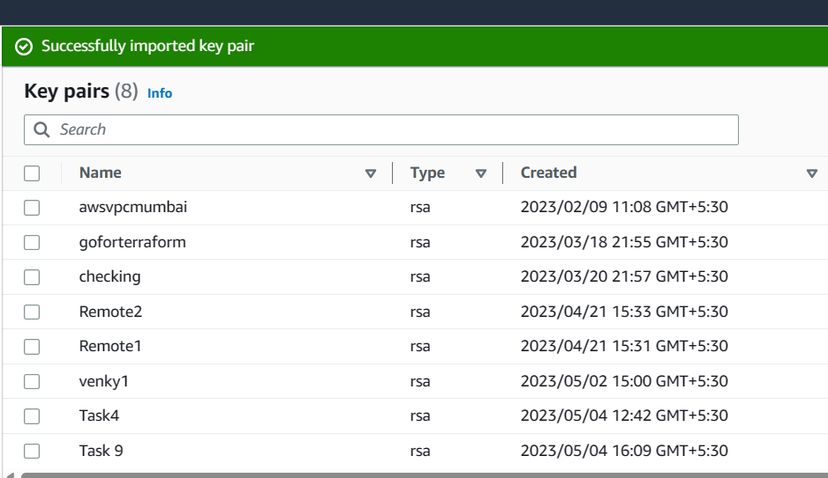

**Task 10 : commands cp/mv/rp/rmdir/wc/head/cut/sort/grep/uniq**

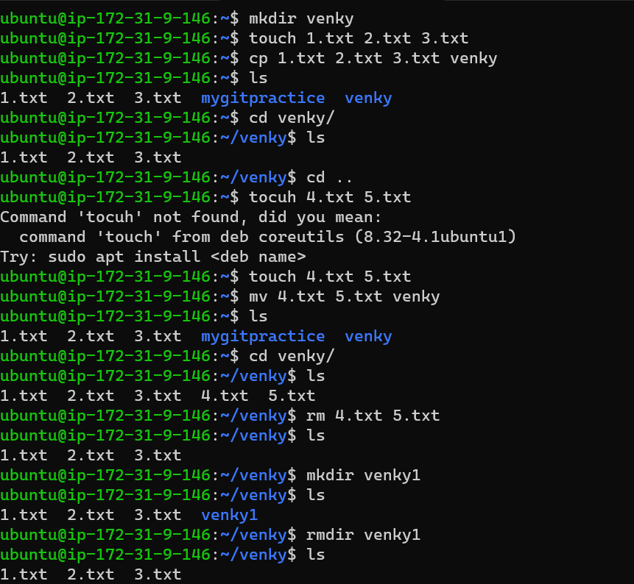

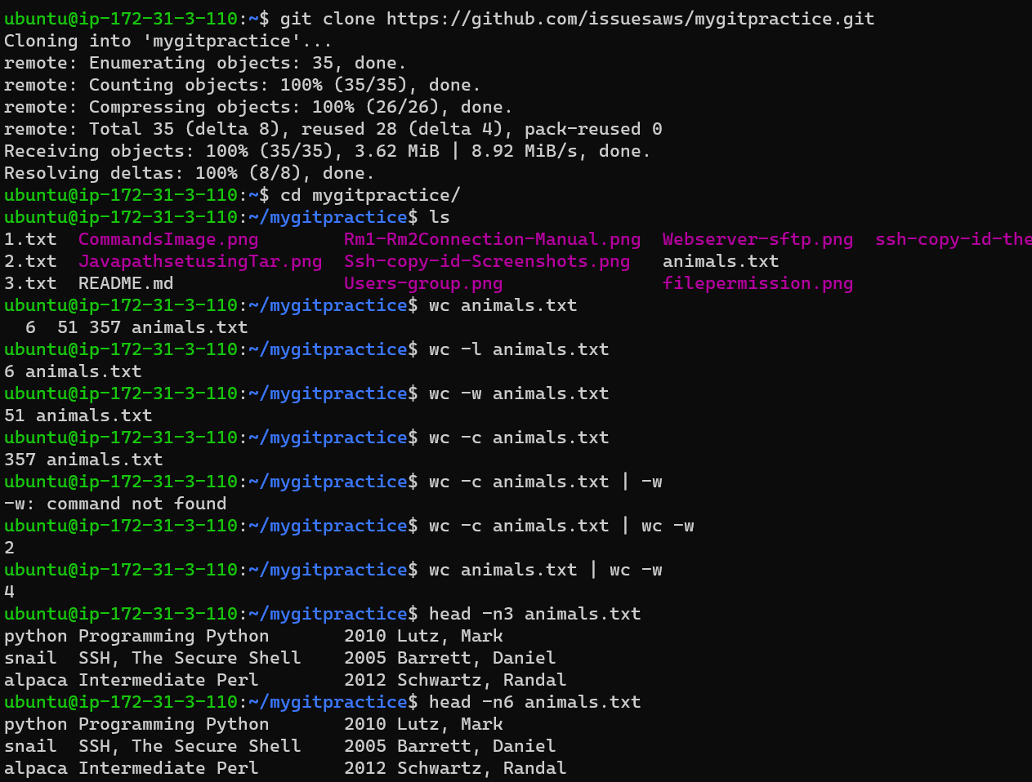

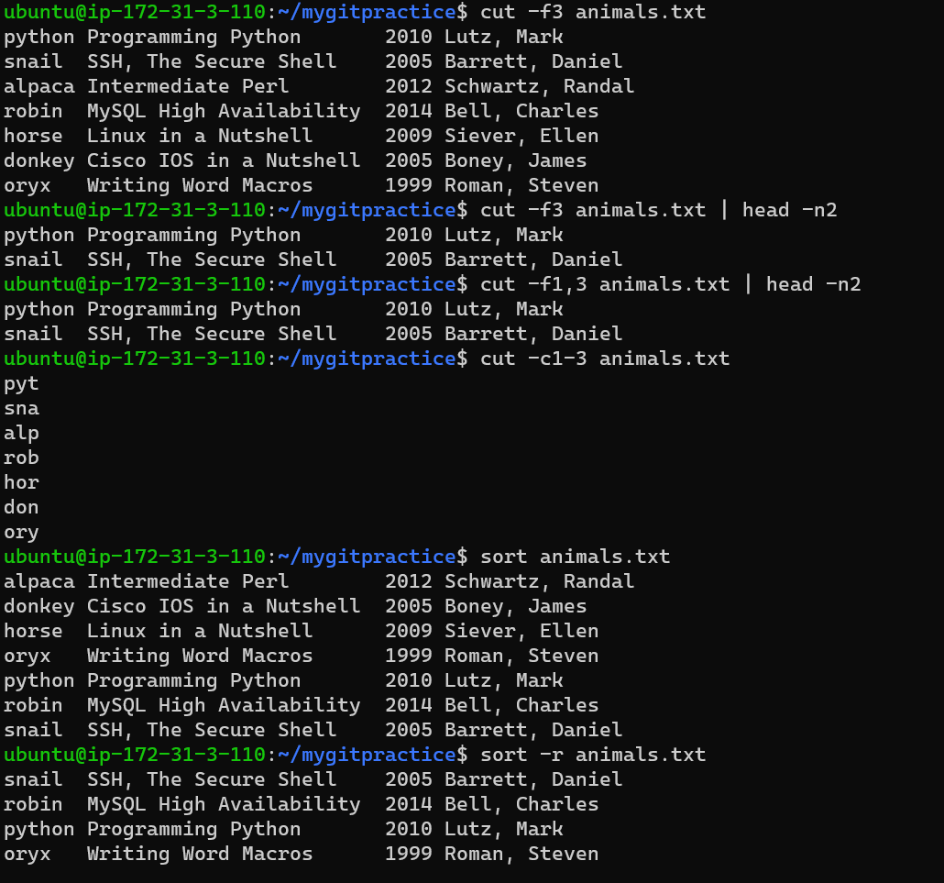

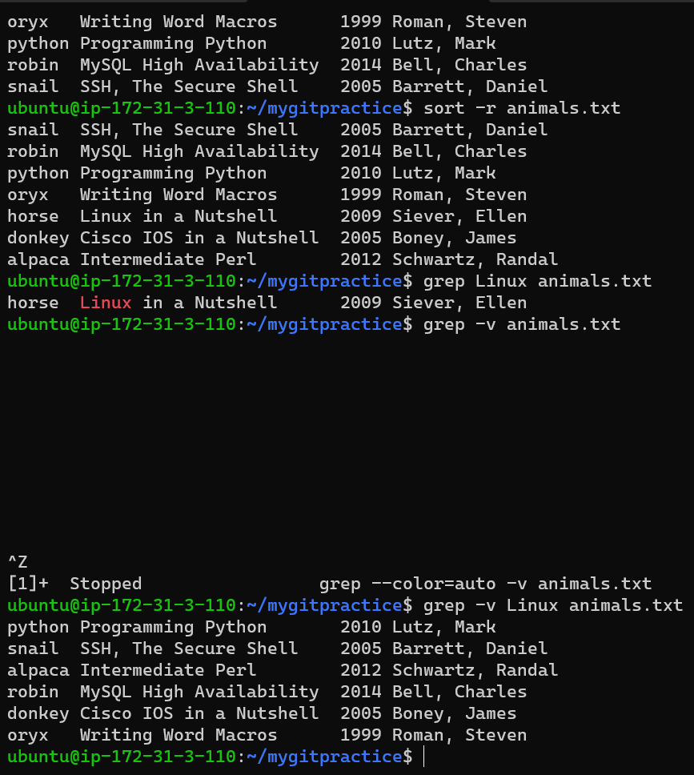

**Task 11 : relative and absolute path**

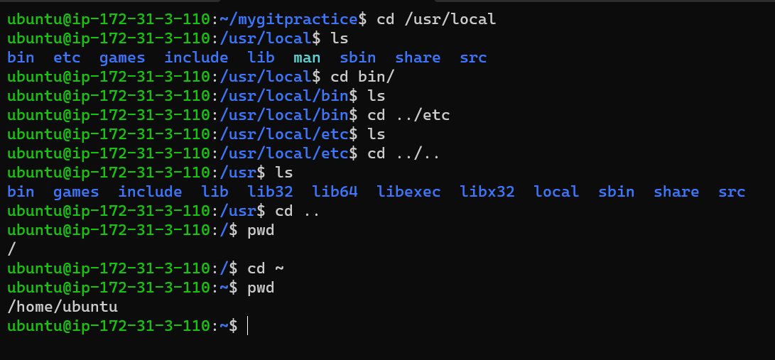

**Task 12 : Establish connection between 2 remote machines using ssh manual procedure**

**Remote 1**

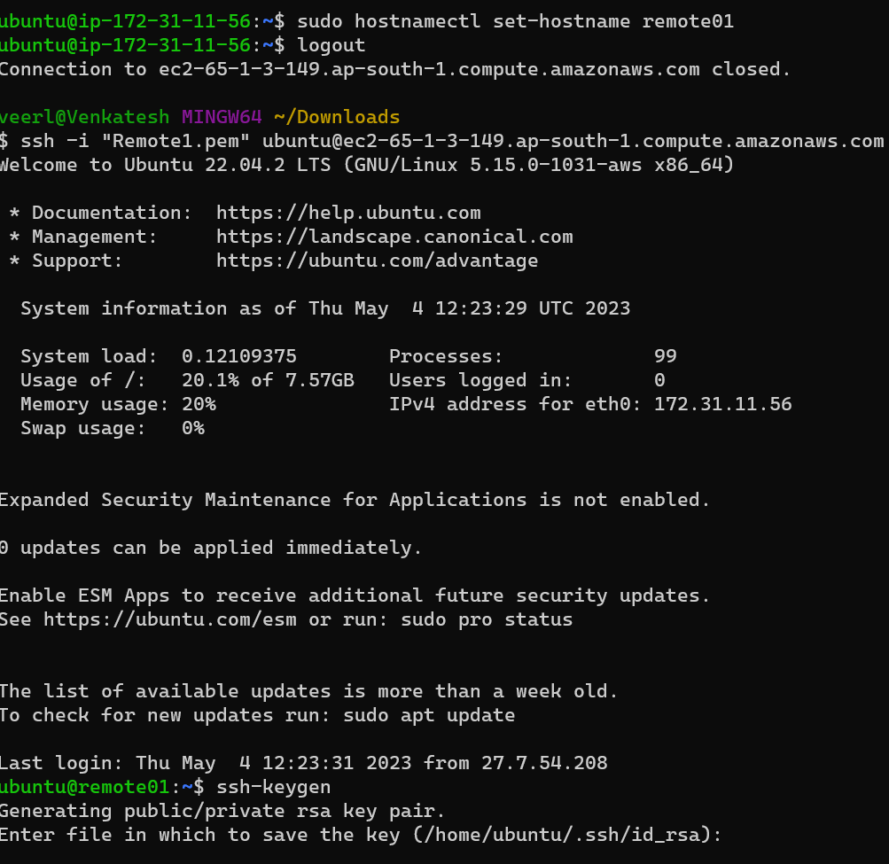

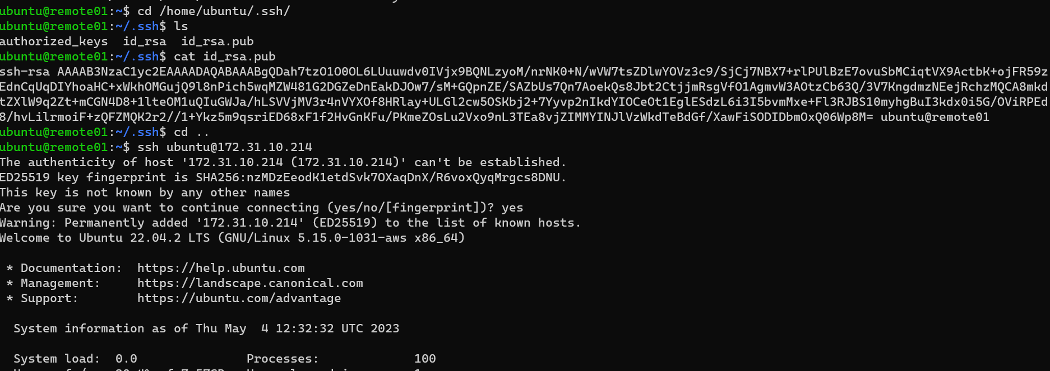

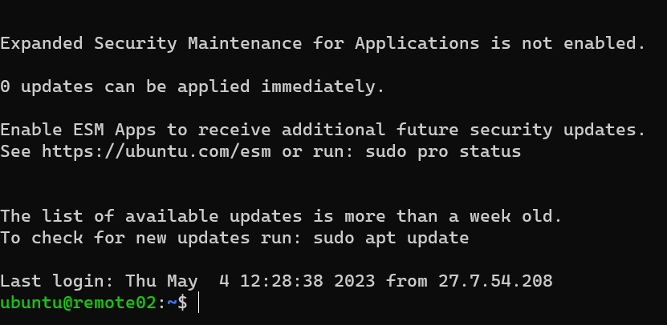

**Remote 2**

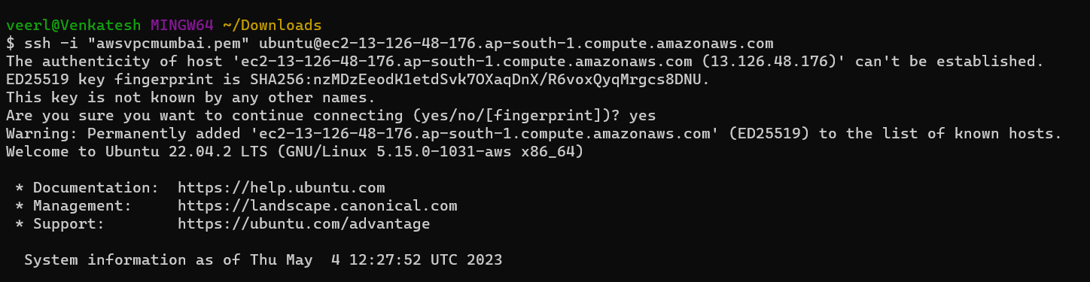

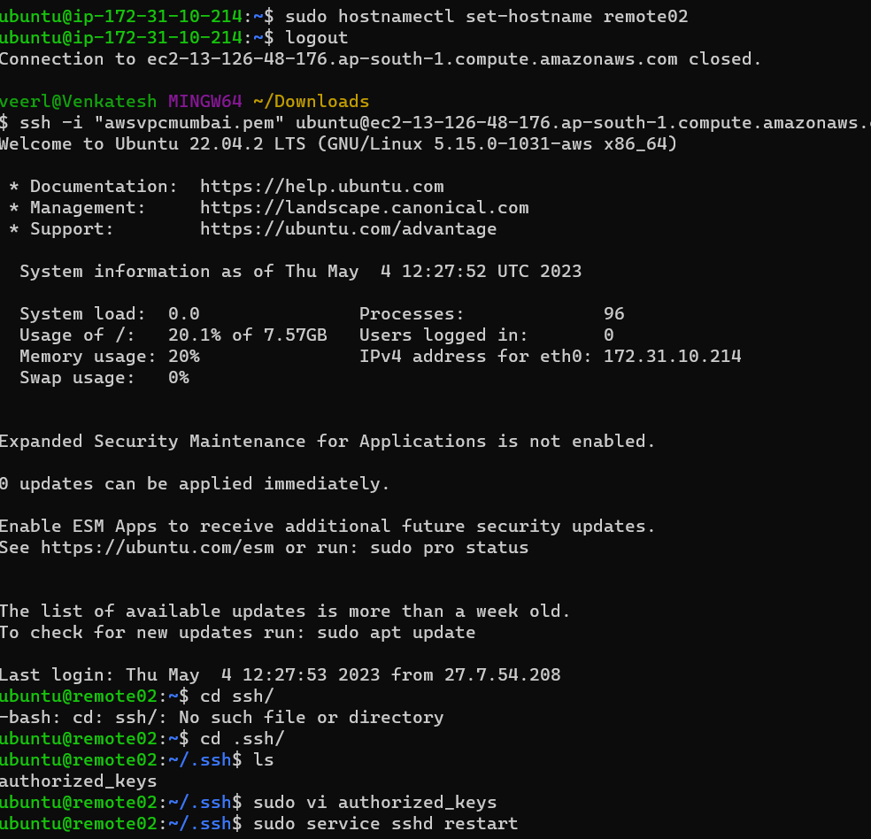

**Task 13 : Vi editor practice and open.vim.com website**

**Task 14: Creating the shell file with some commands and execute/run it**

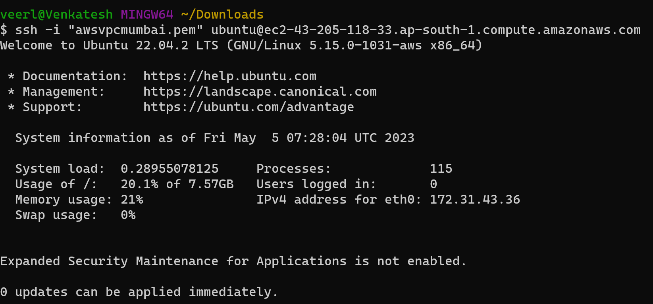

Sudo vi venky

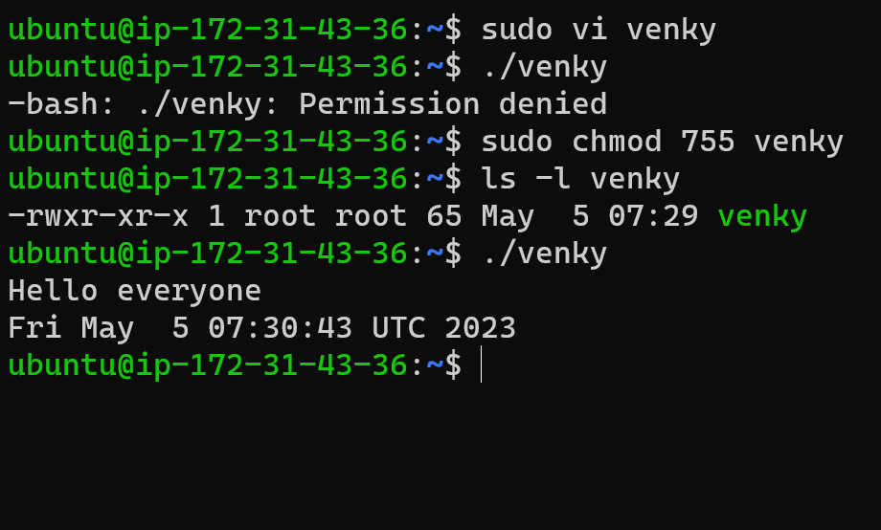

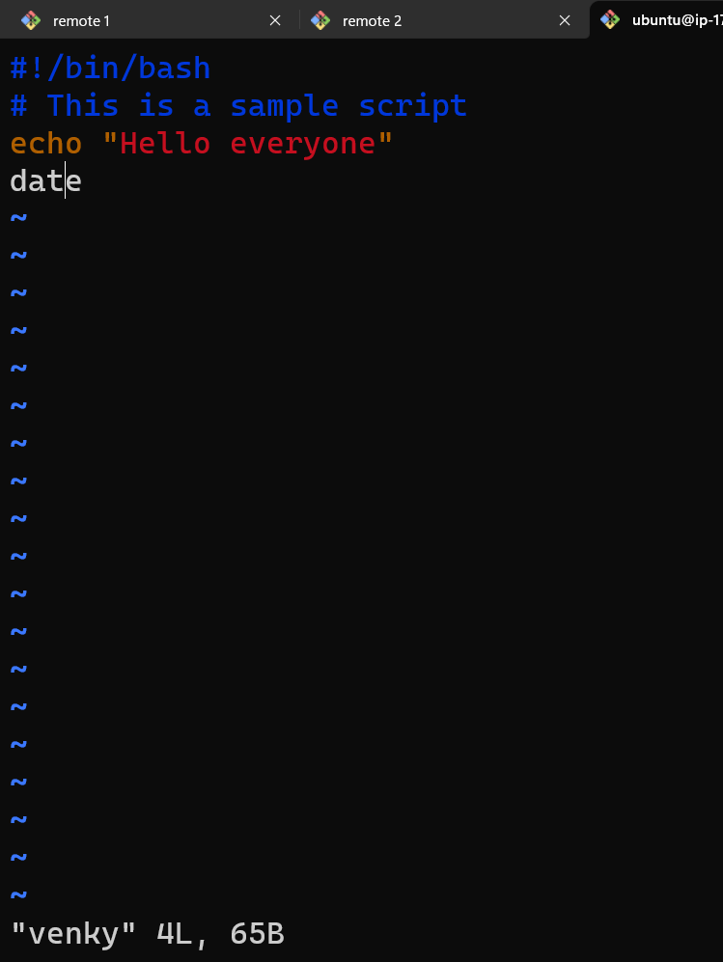

**Sudo vi venky1**

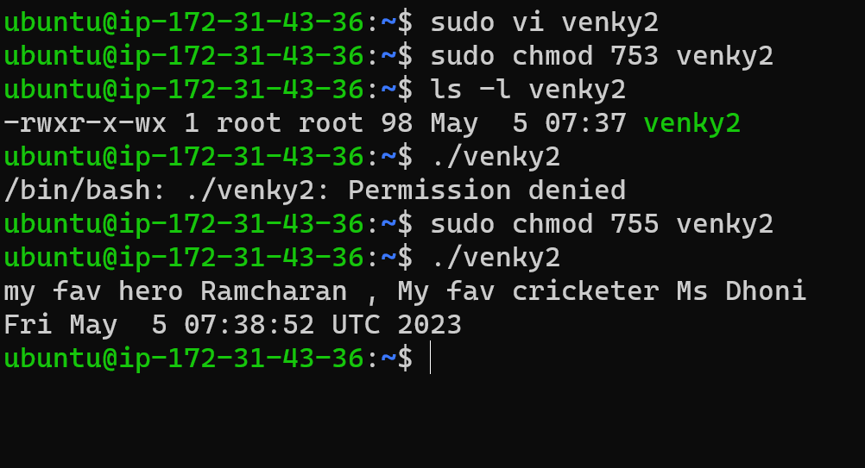

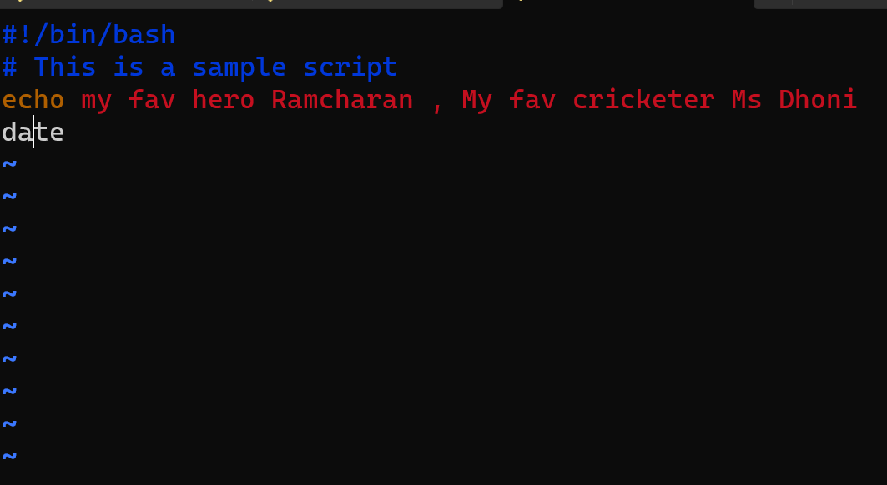

**Sudo vi Venky1 - apache2**

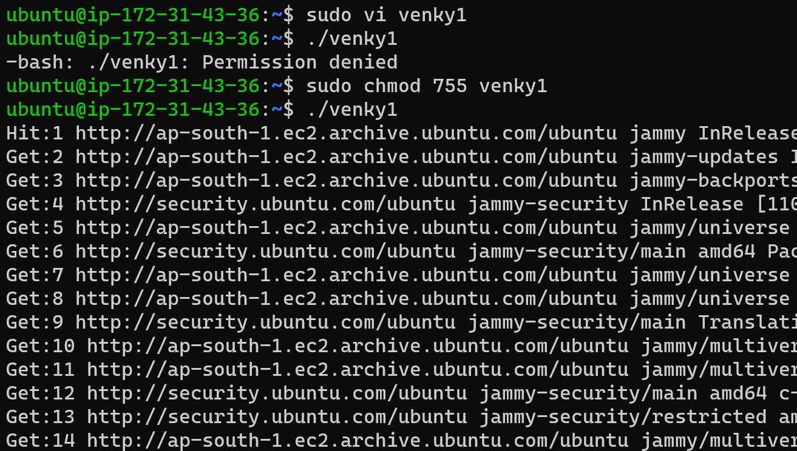

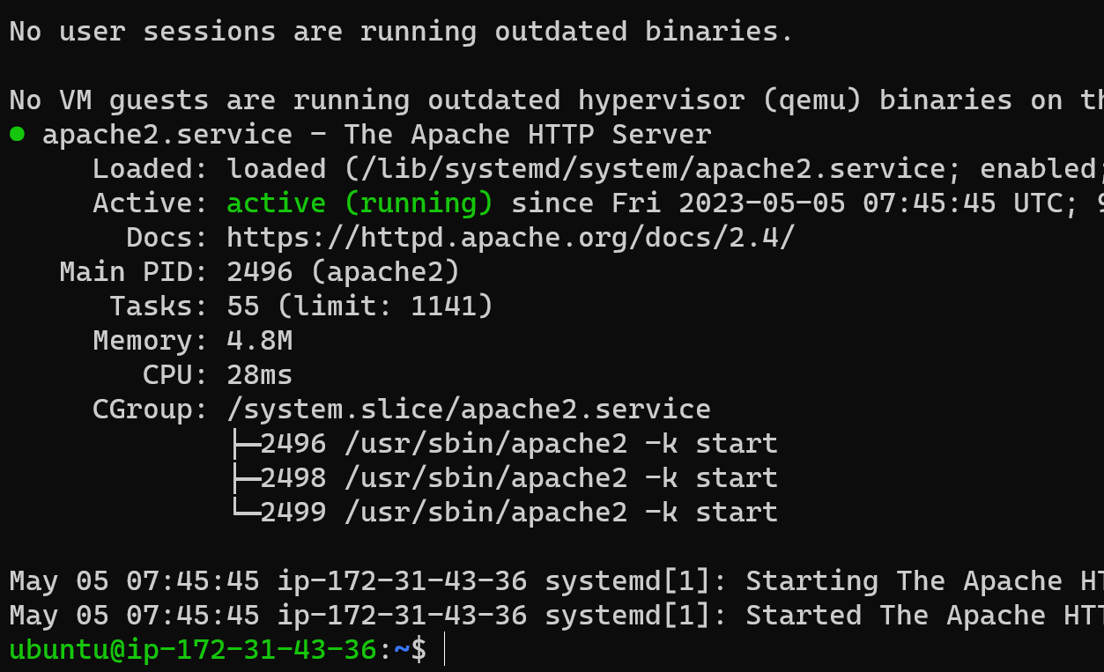

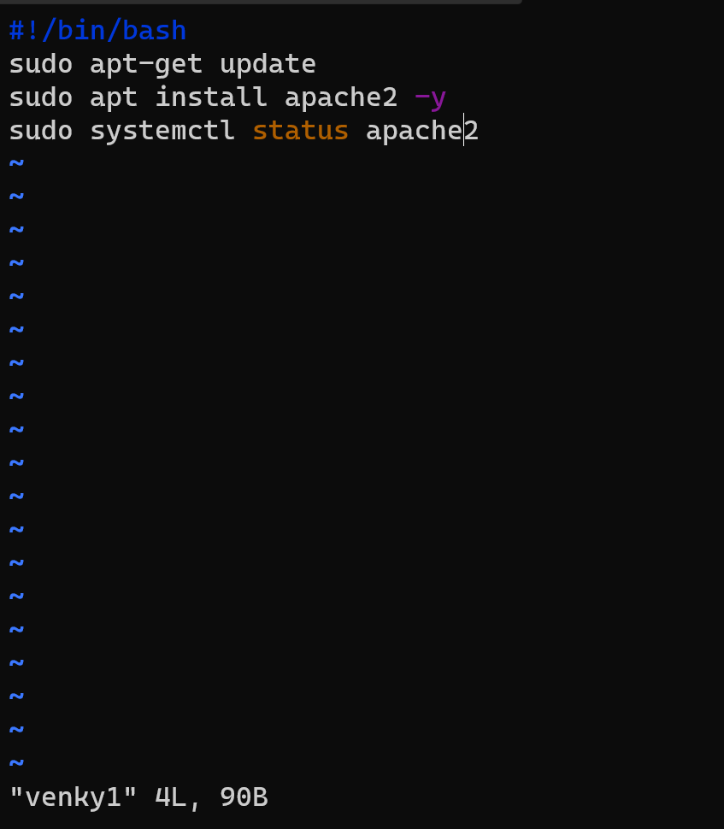

**Copy Ubuntu machine public ip address in browser getting apache2**

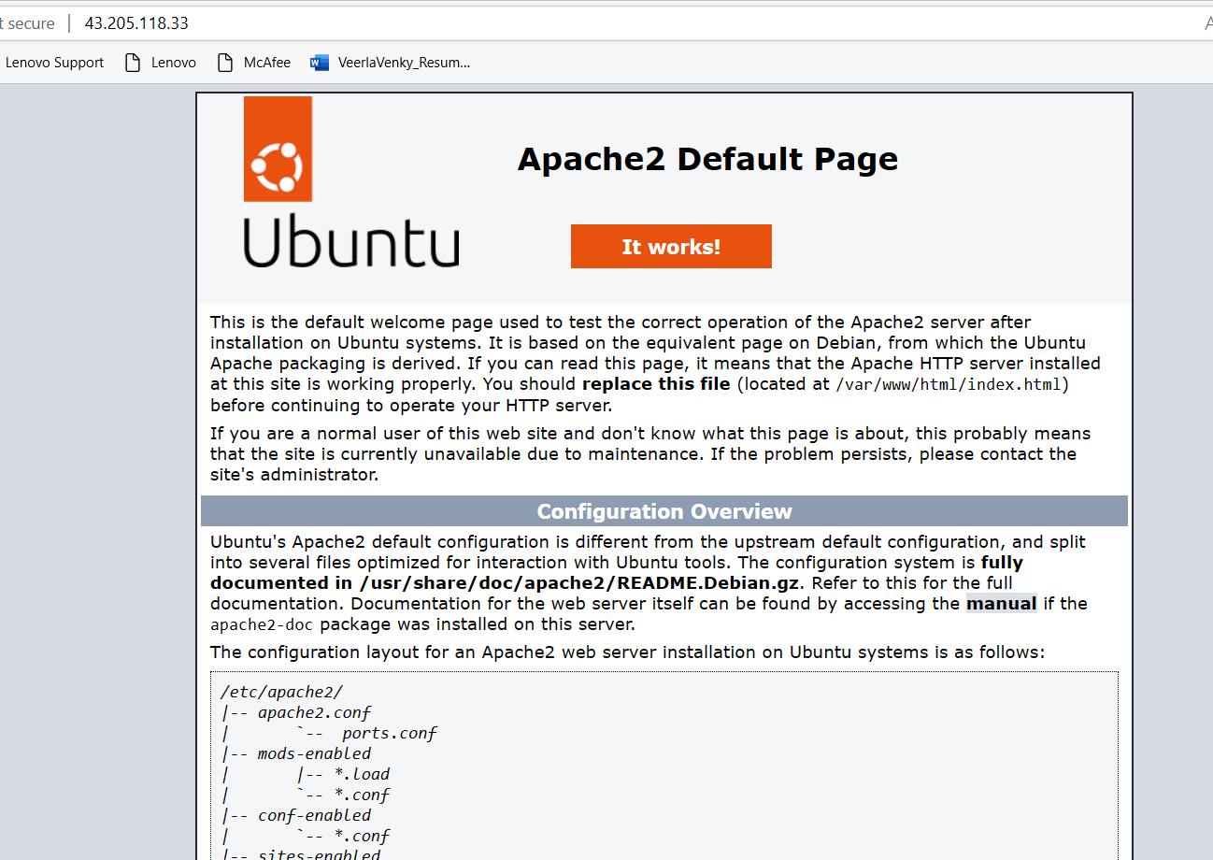

**Task 15 : Create 50 files using a single command**

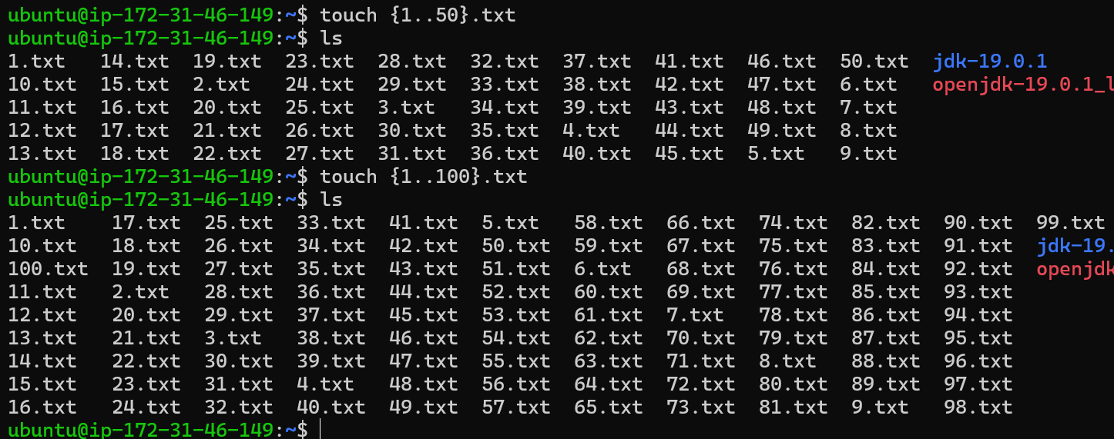

**Task 16 : Create a Ec2 and install Apache2/Tomcat web server on Ubuntu/Centos and Access it through**

**UBUNTU – Apache 2**

**Sudo apt upadte**

**Sudo apt install apache2 -y**

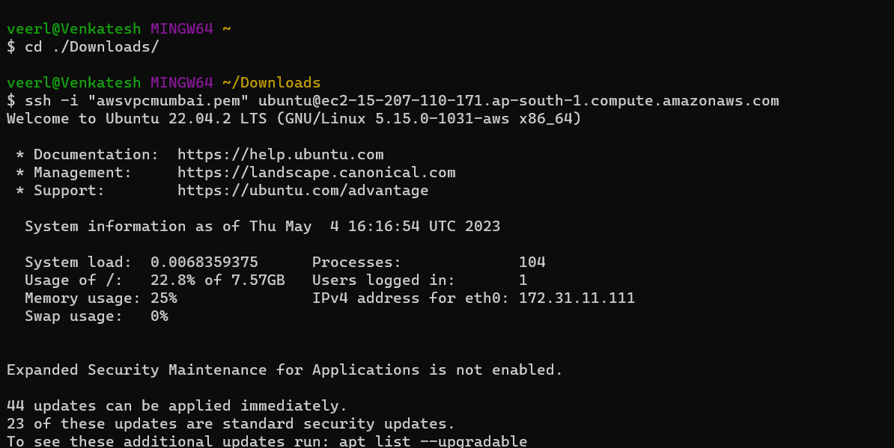

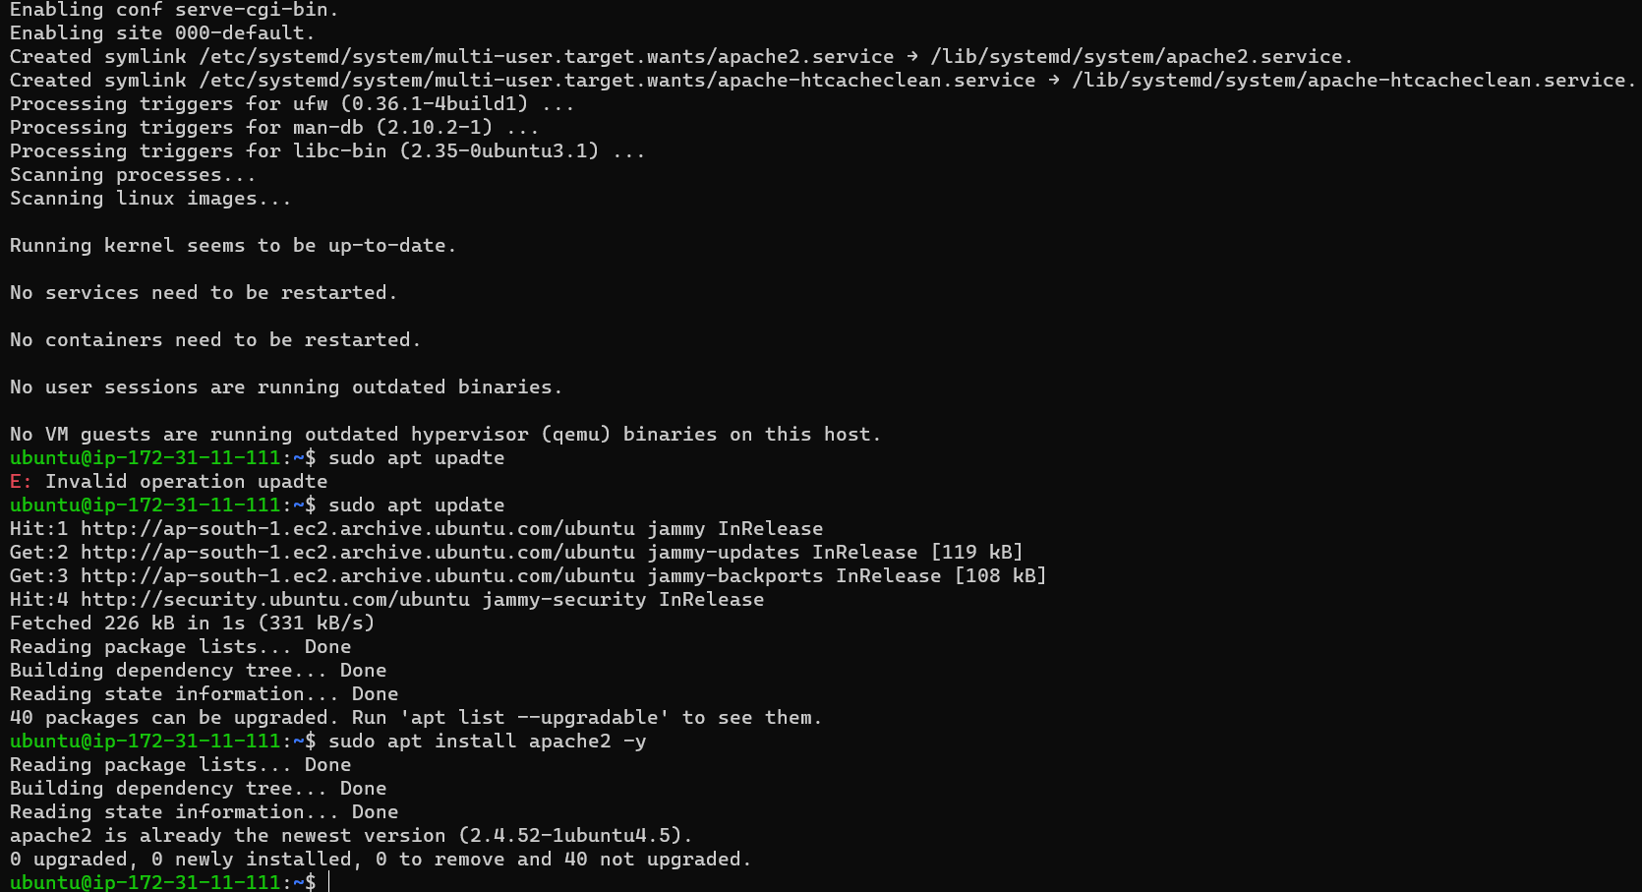

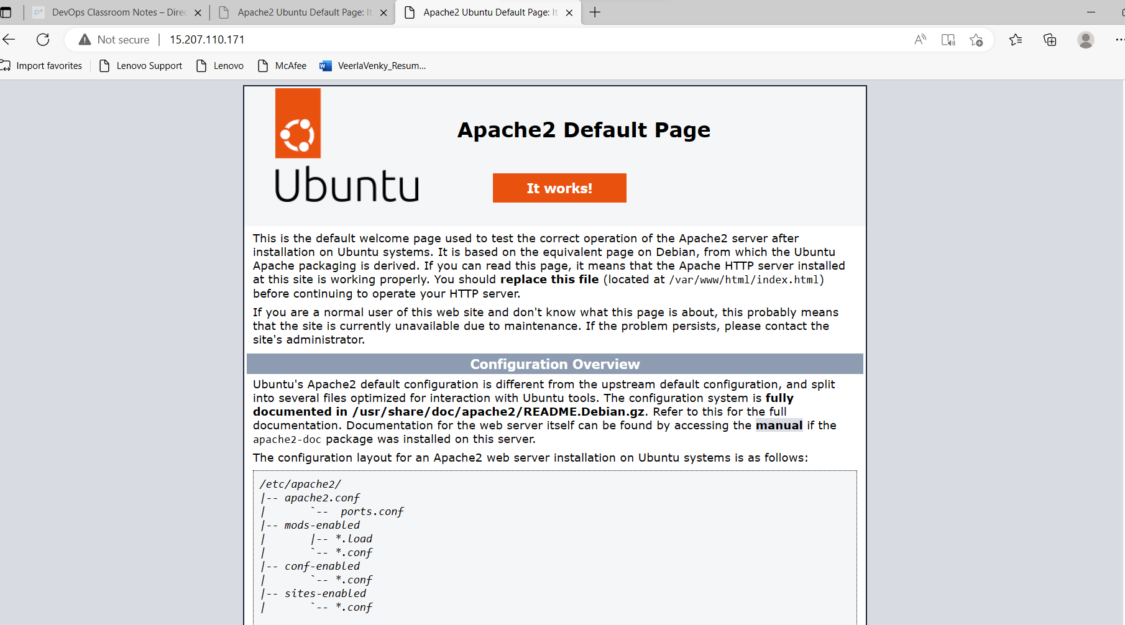

**Tomcat9 – Ubuntu**

**Sudo apt install tomcat9 -y**

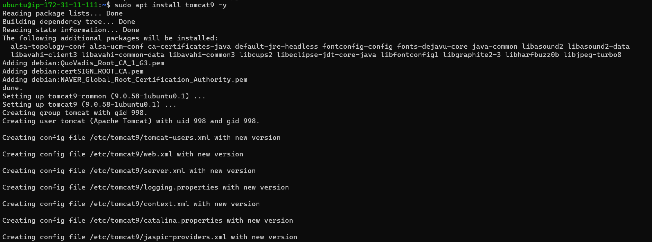

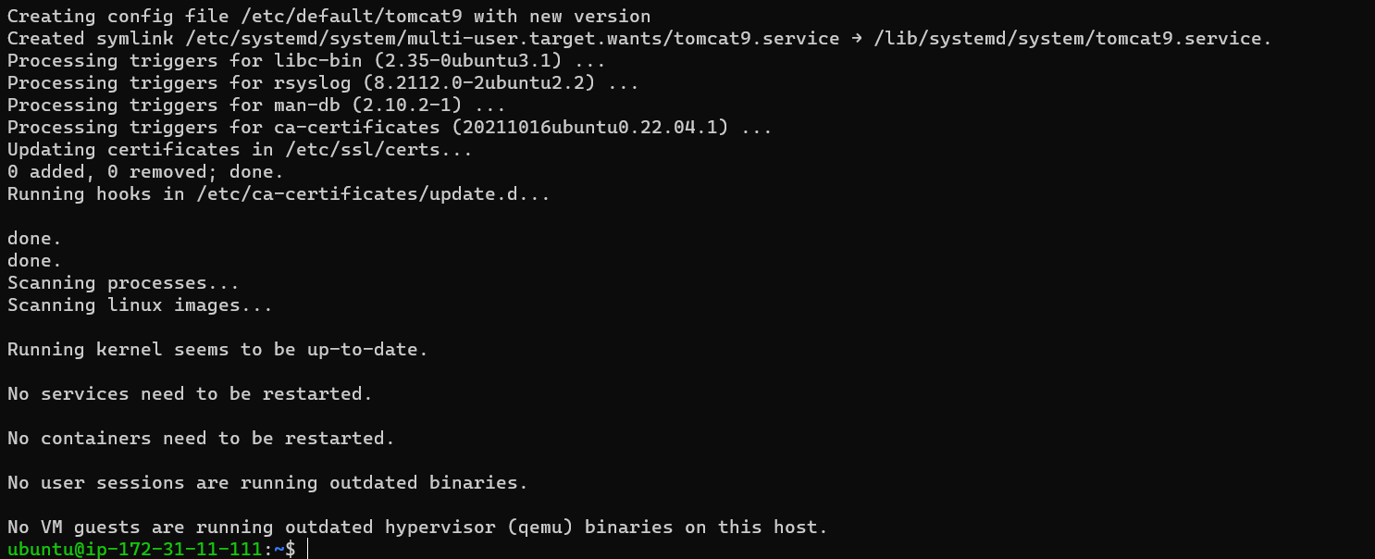

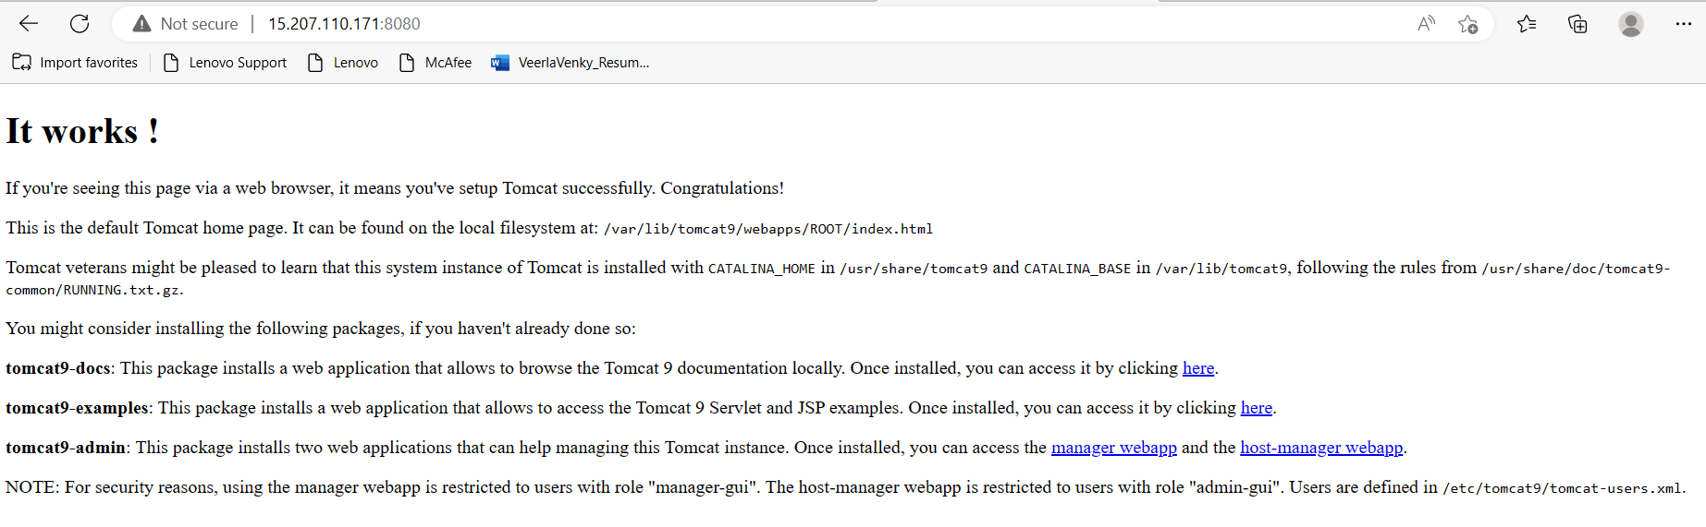

**Centos – Apache2 httpd --**

**Sudo yum update**

**Sudo yum install httpd-y**

**Sudo systemctl start httpd.service**

**Sudo yum list installed *httpd\***

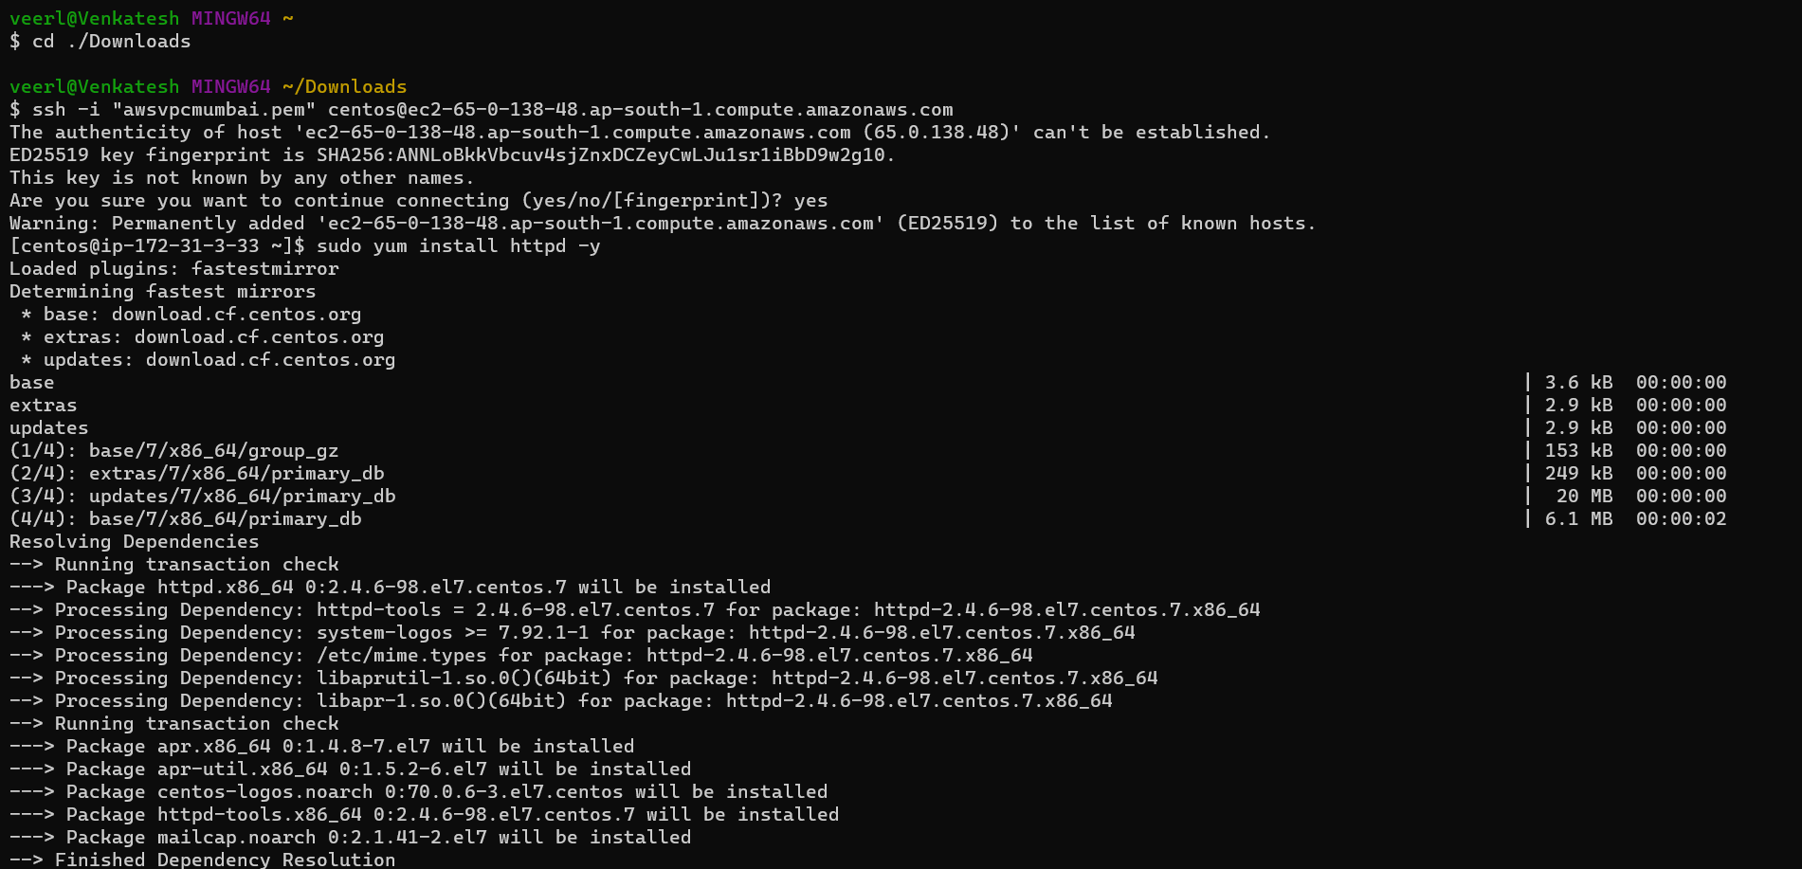

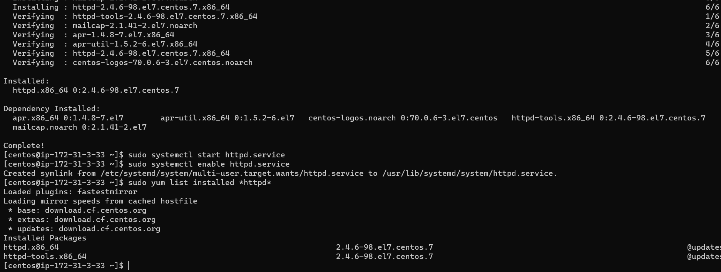

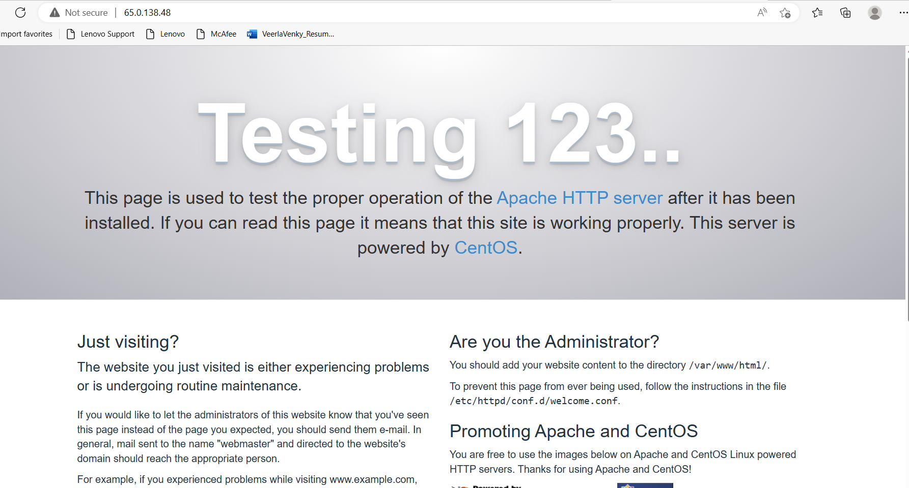

**Task 17 : Upload any image inside the web app path and access it through the web**

**Connecting to machine**

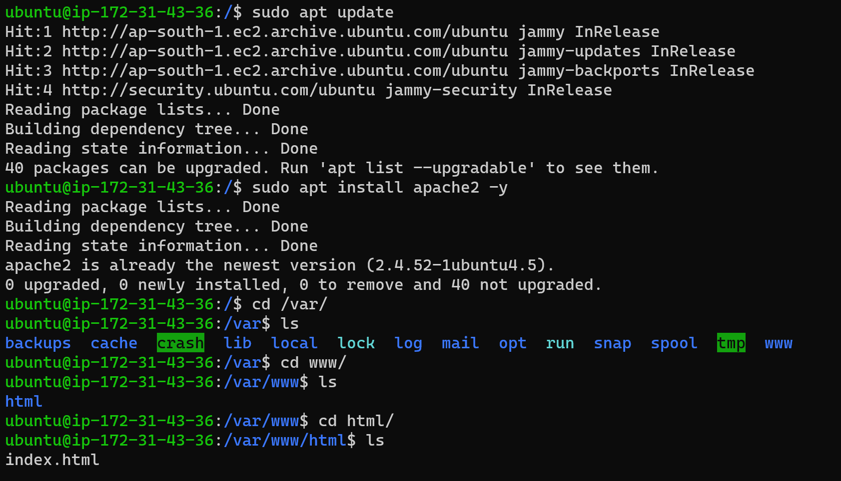

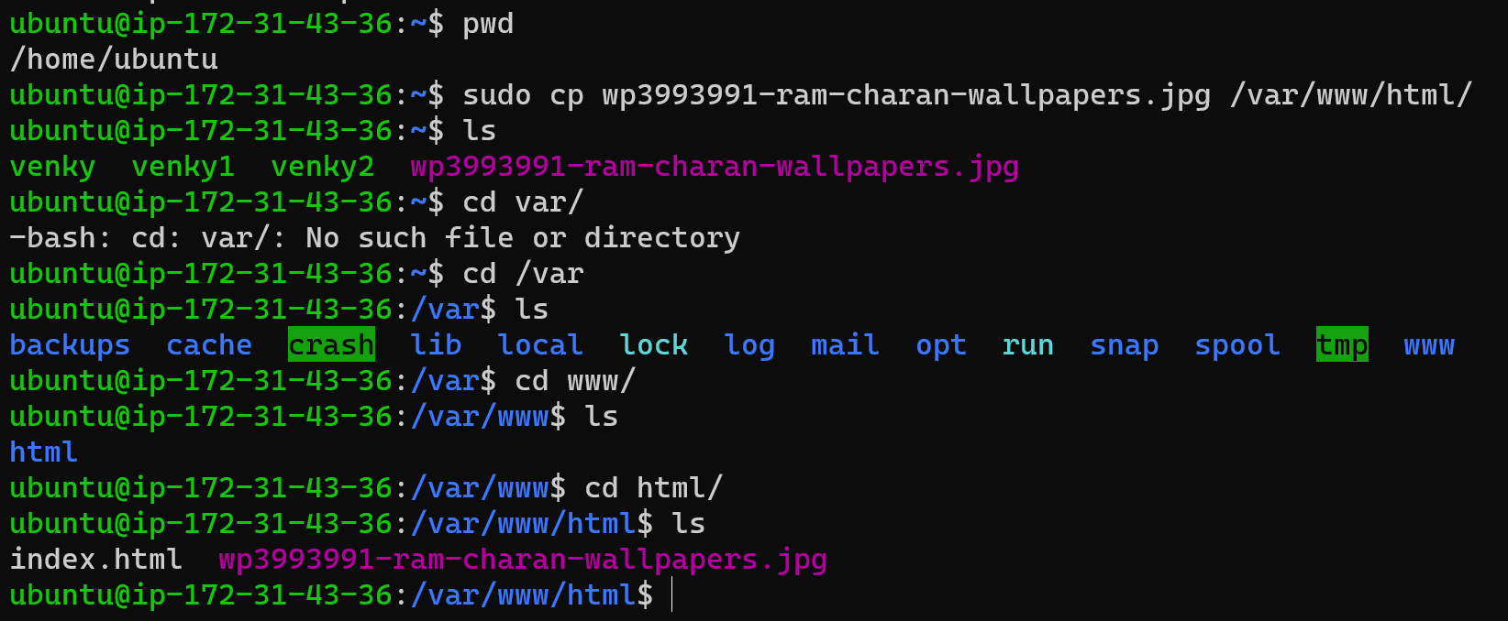

**Access another login into sftp and upload image**

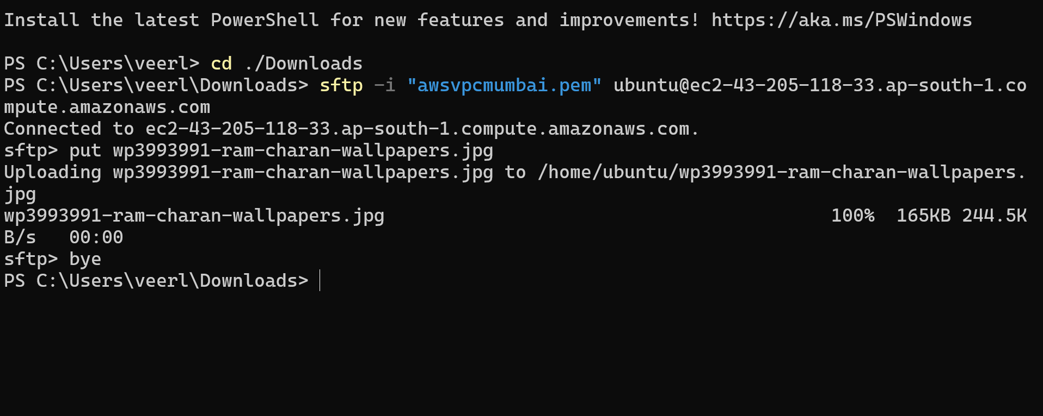

**SEARCH IN Browser http://publicip/image name**



**Task 18 : Add users and Groups to the sudoers file , enable password based autenication passwordless method.**

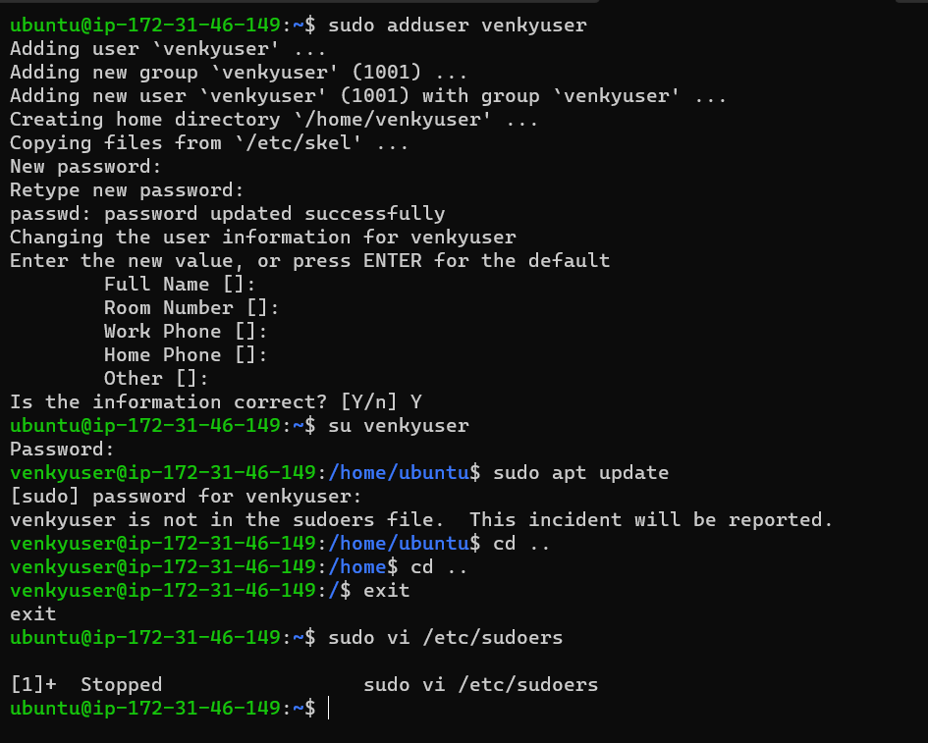

**Before adding user to sudoers file**

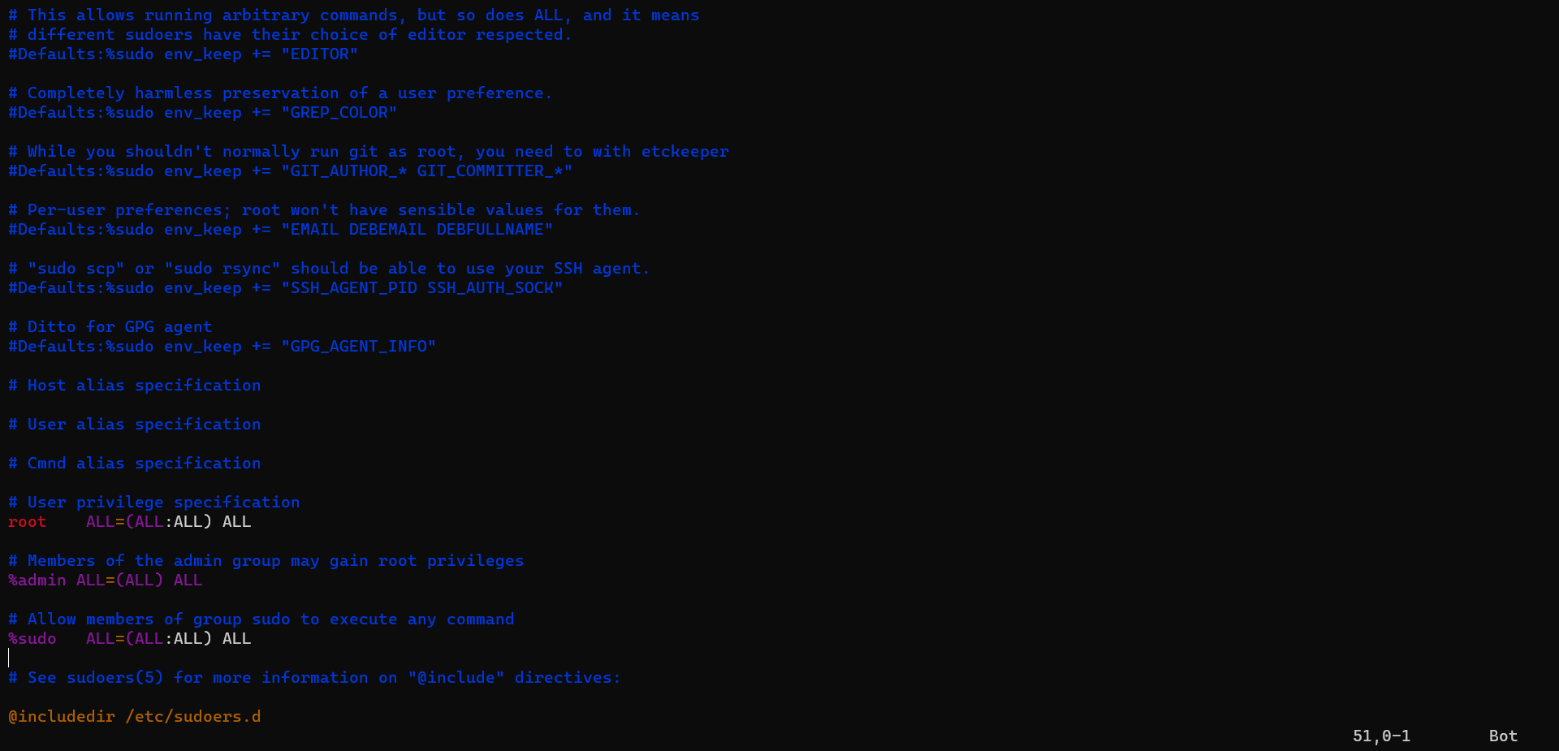

**After Adding to venkyuser to sudoers file Give the permission nd password authenication to venkyuser**

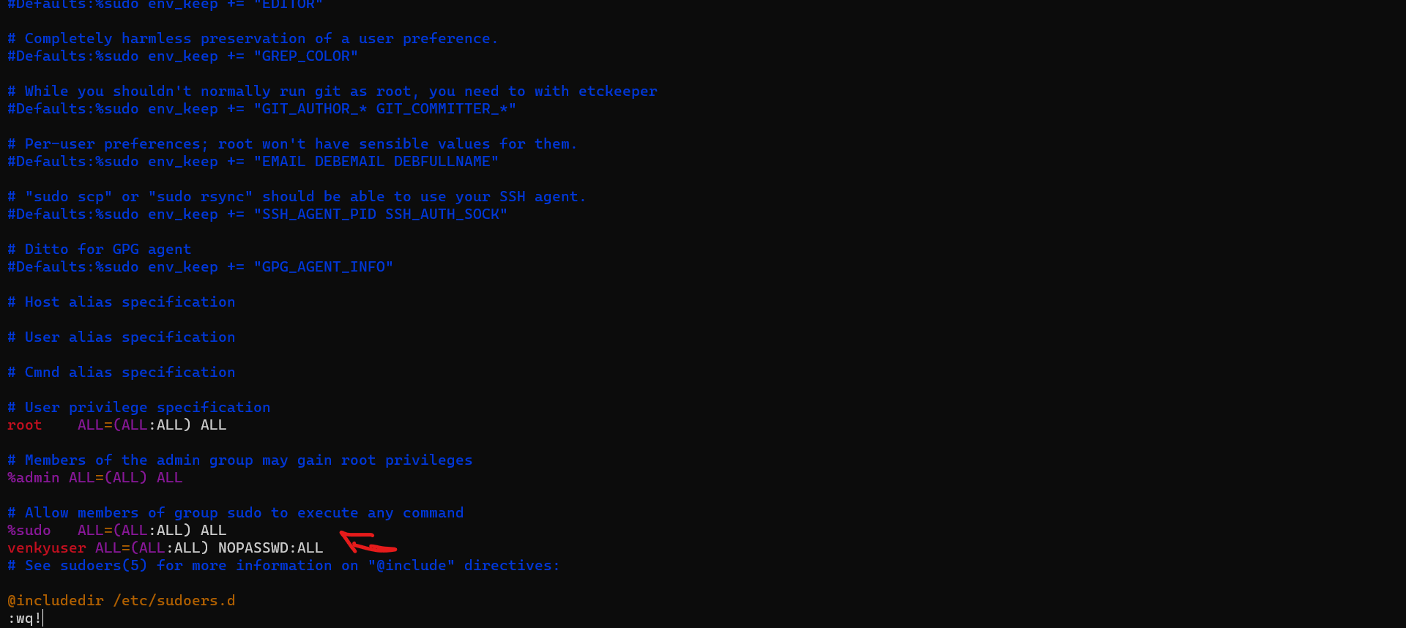

After saving the file

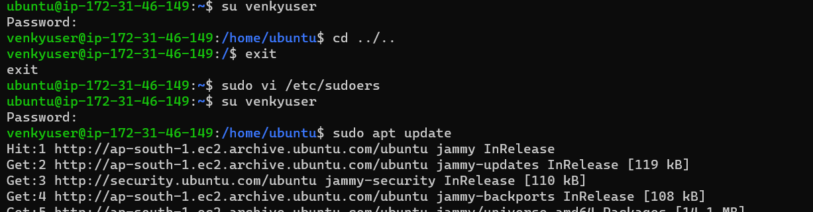

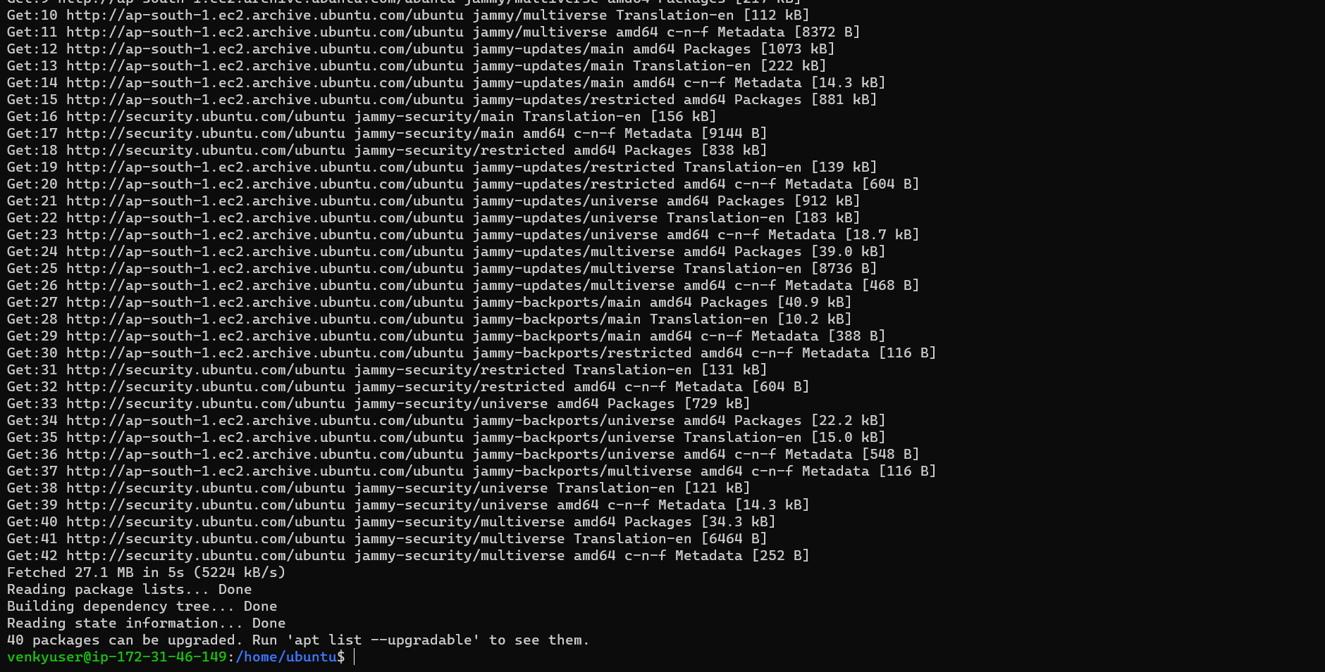

**Task 19 : Generate ssh and Connect 2 Linux machines Using ssh-copy-id**

**Remote 01**

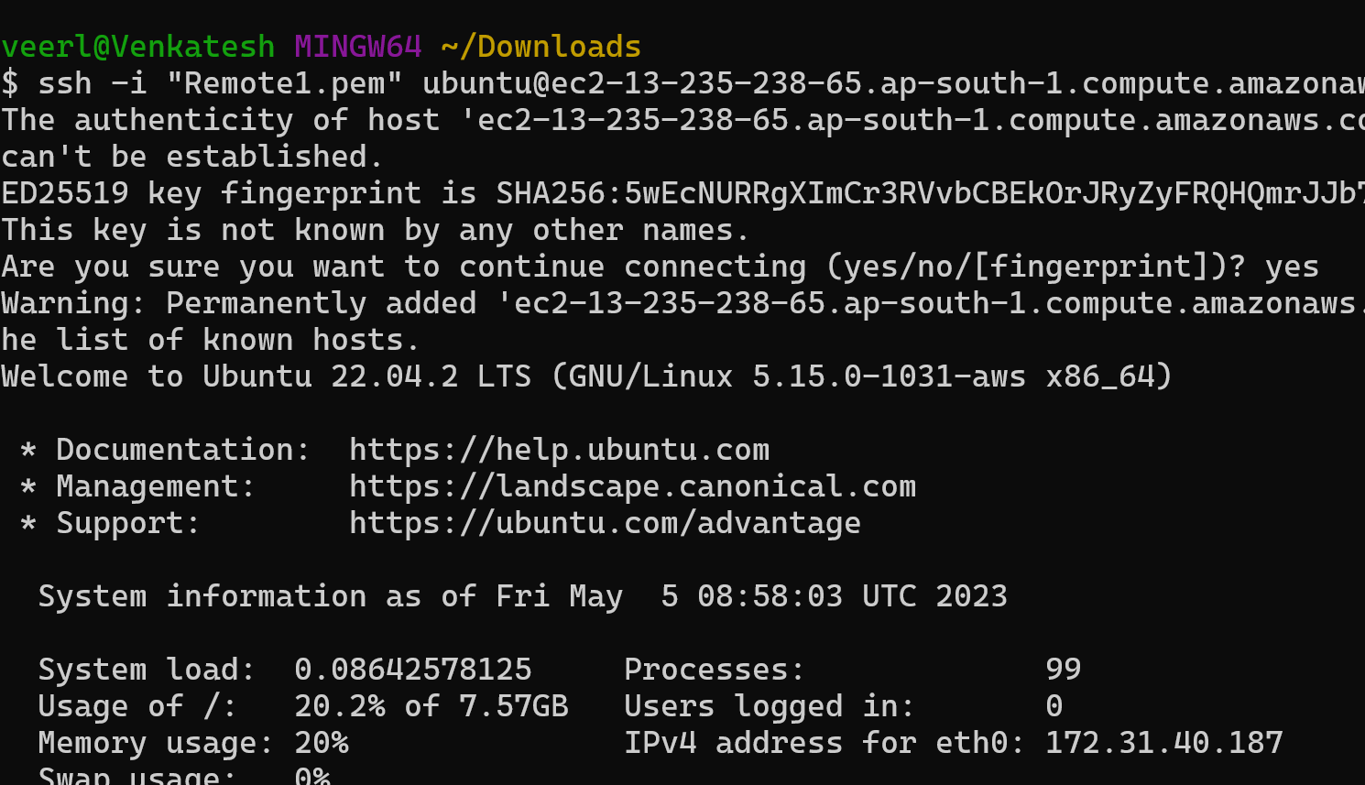

Set hostname Remote 01

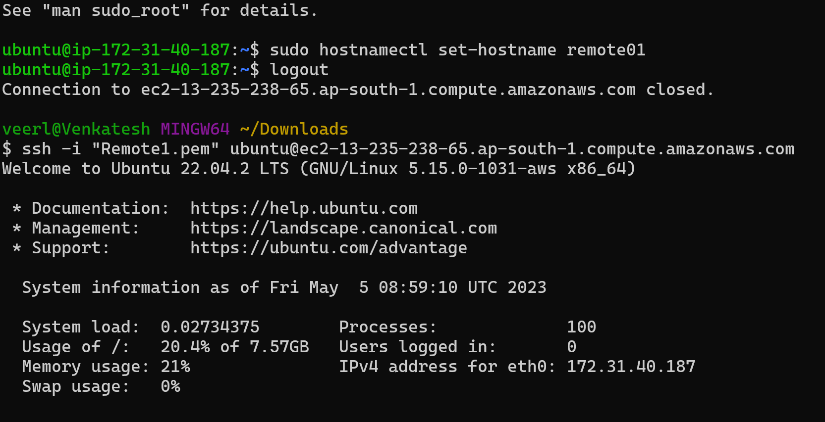

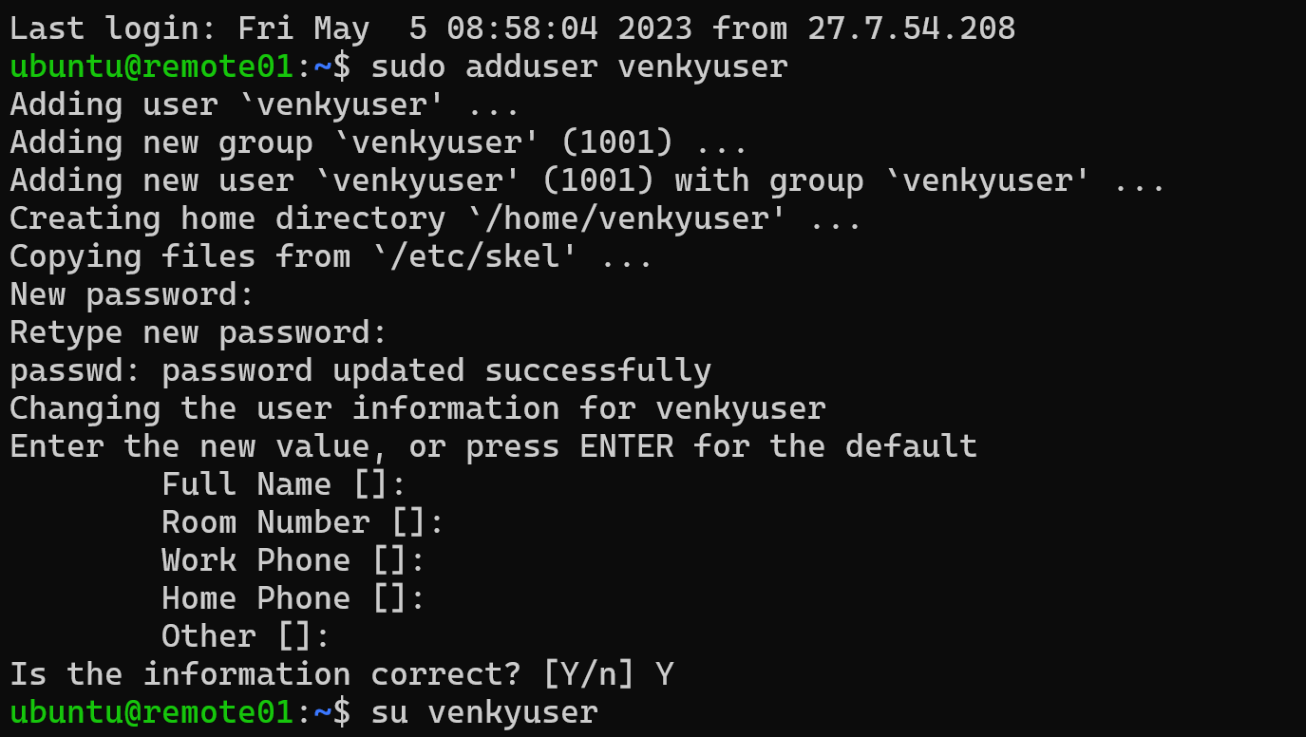

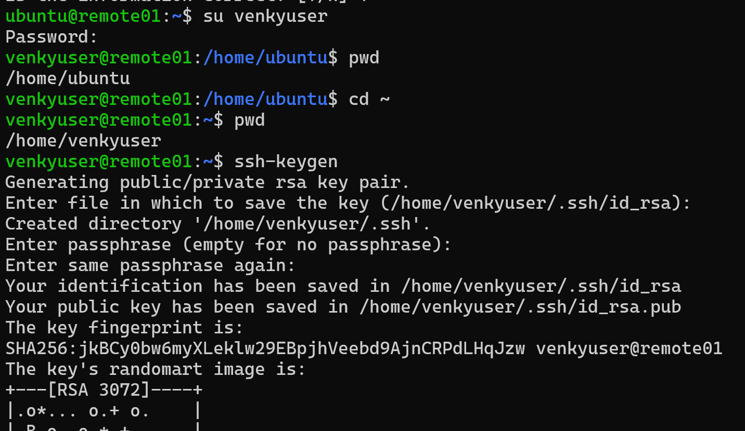

**Remote 02**

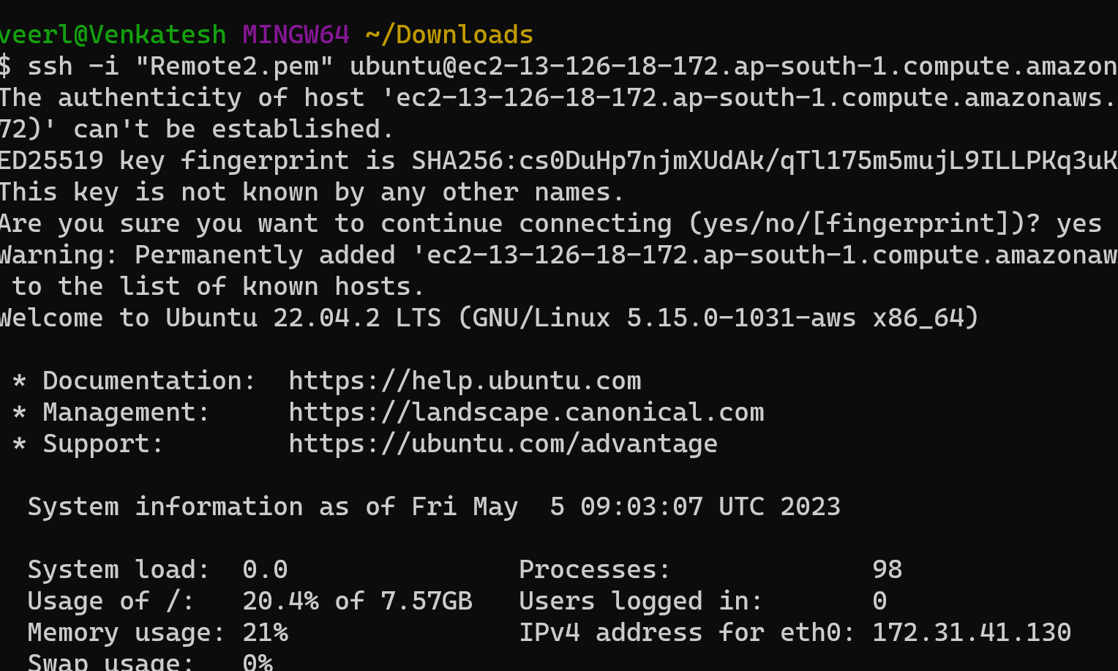

**Set hostname**

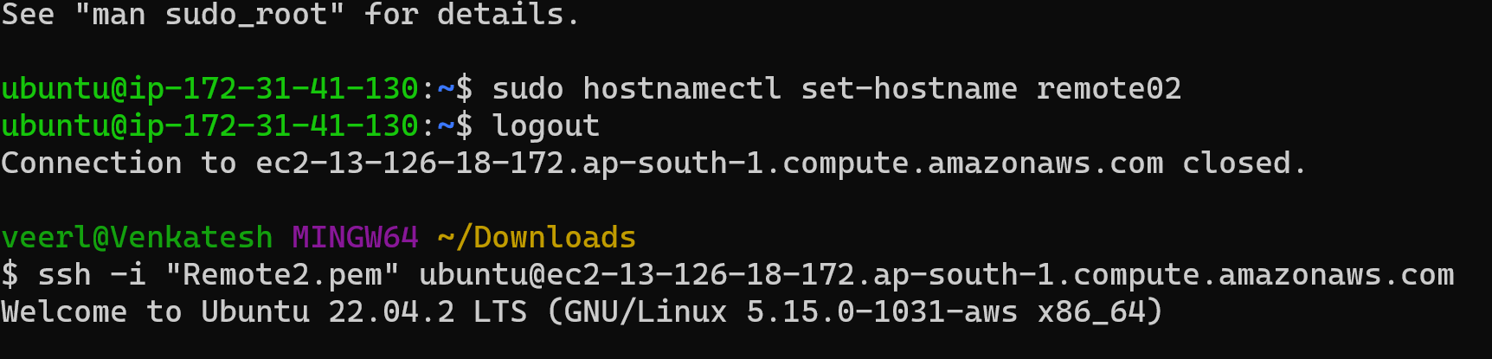

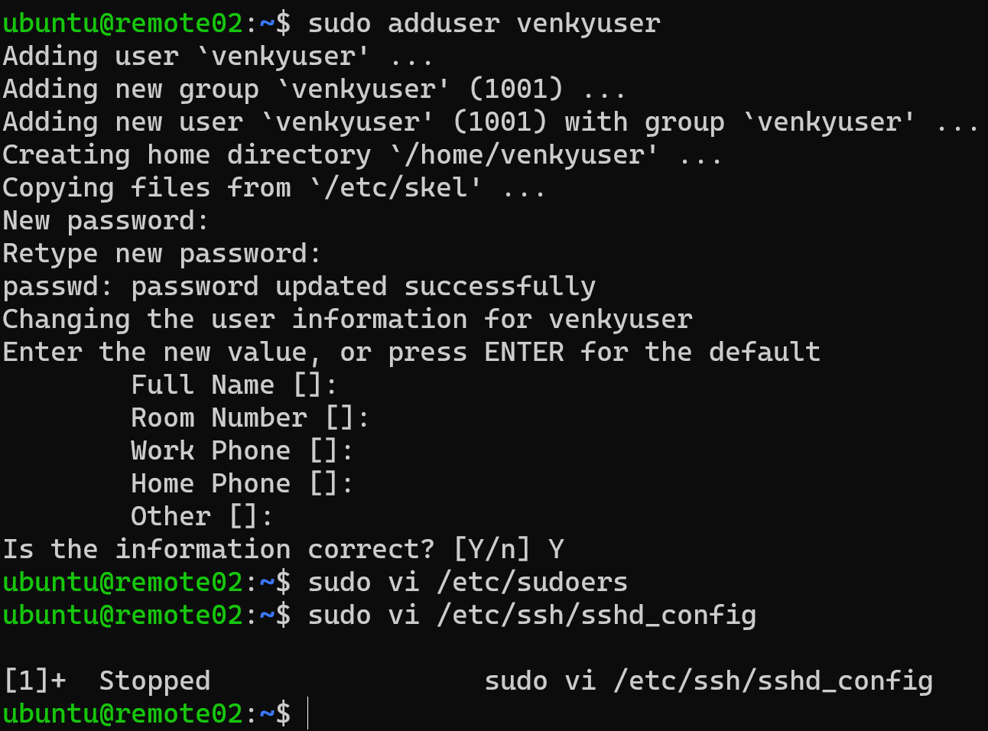

**Sudo vi /etc/sudoers**

**Add user to sudoers file**

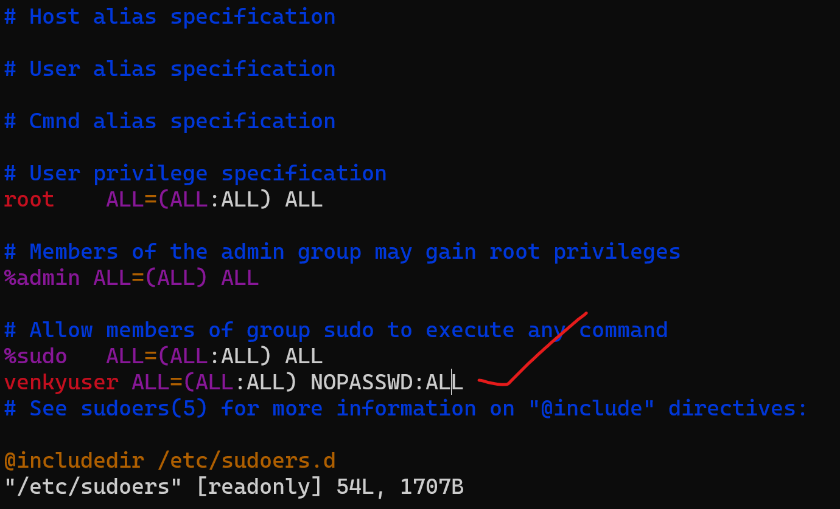

**Sudo vi /etc/ssh/sshd_config**

**PasswordAuthenication change no to yes**

P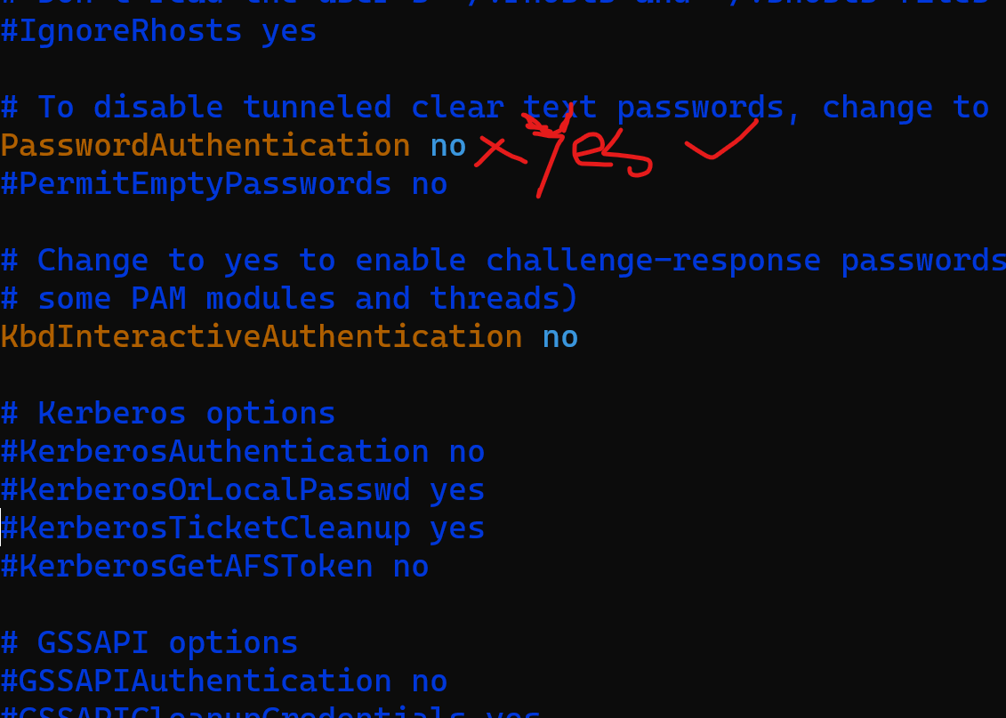

**After Changing no to yes**

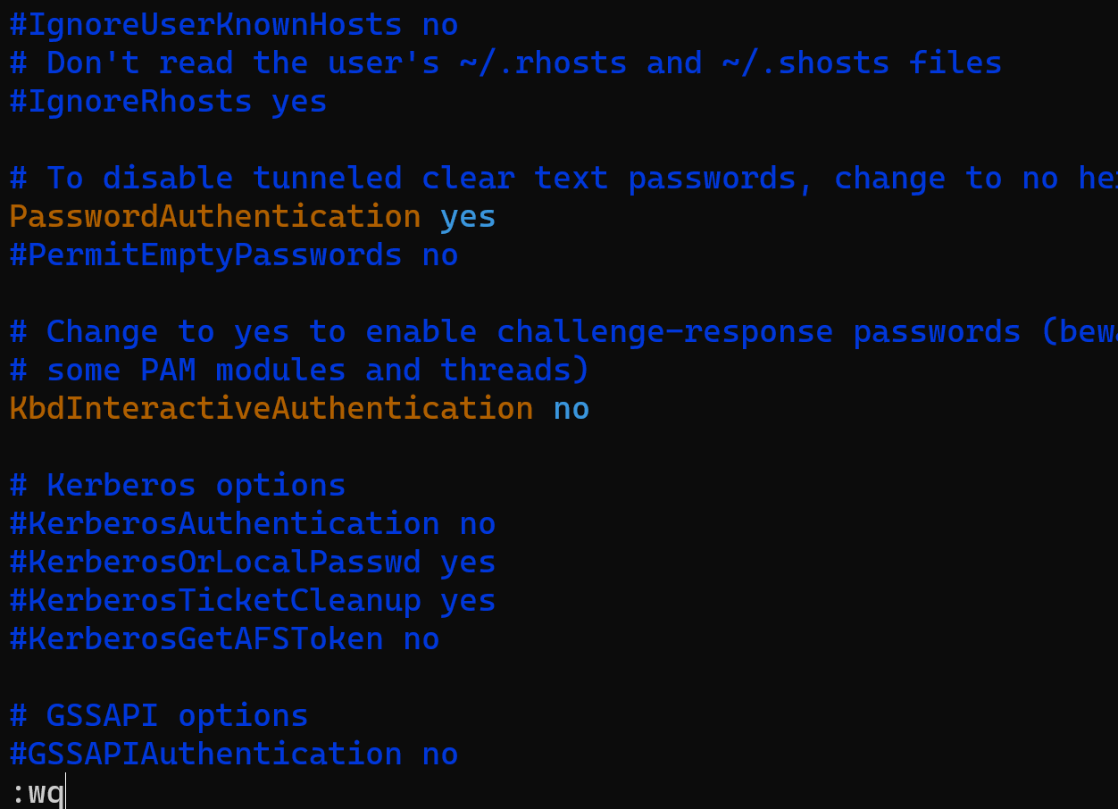

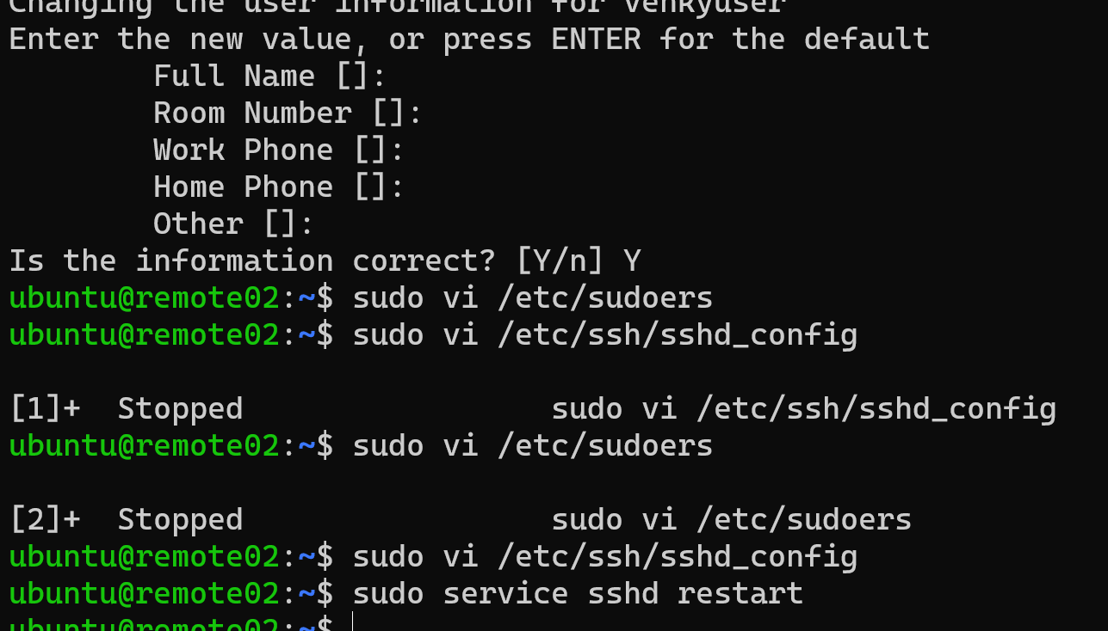

**Login to remote 01**

**Ssh-copy-id username@private ip address remote 02**

**After key added**

**Ssh private ip address remote 02**

r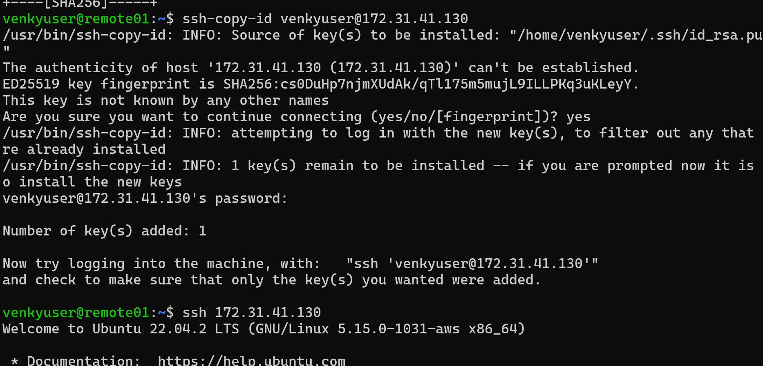

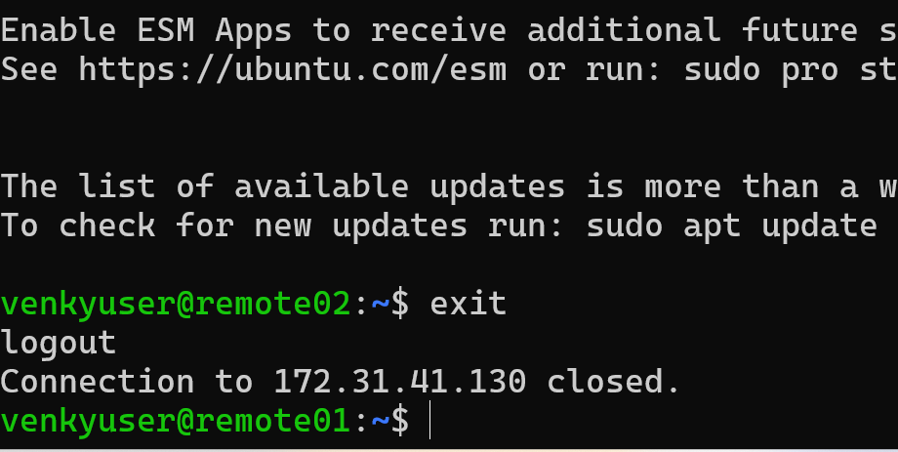

**Task 20: Installing a web server on Ubuntu and centOS During Ec2 Creation Using User Data**

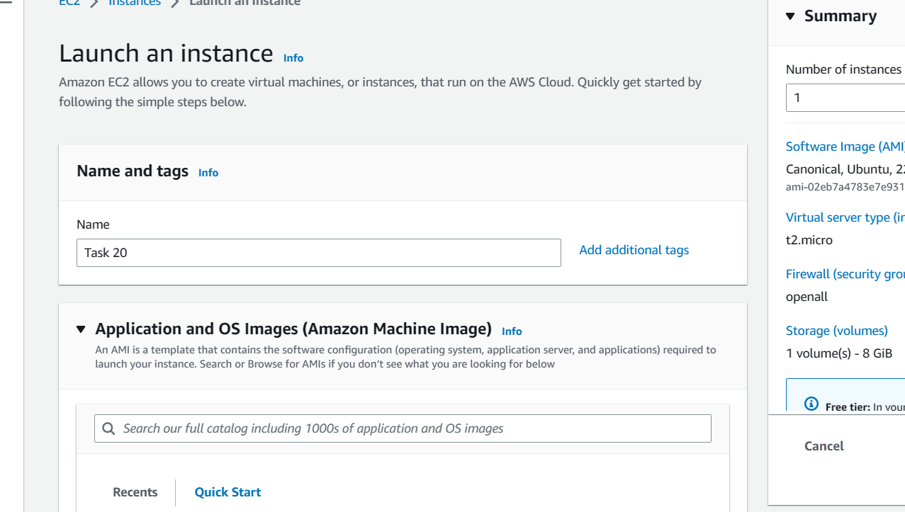

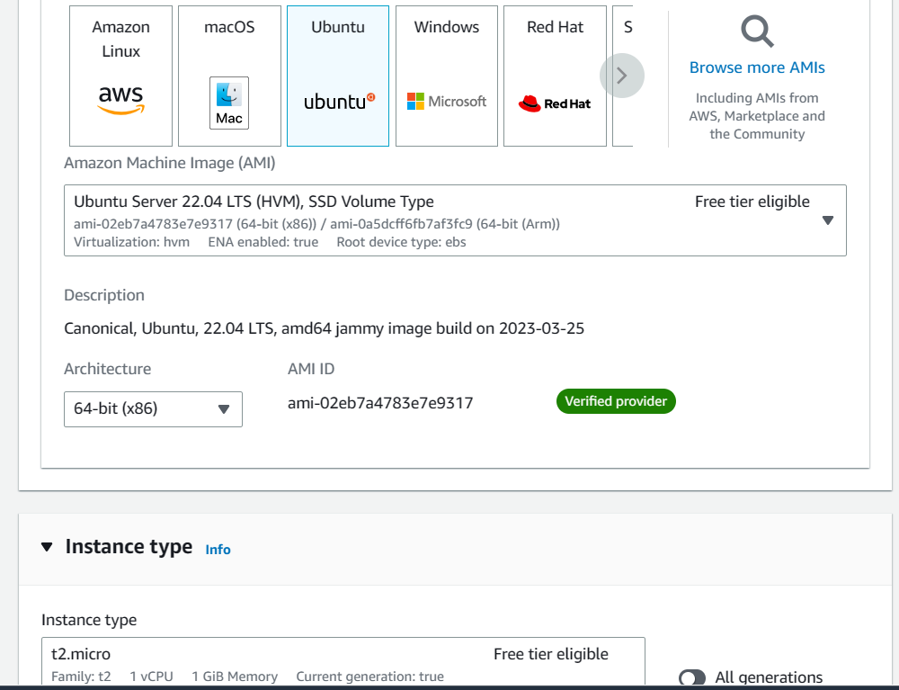

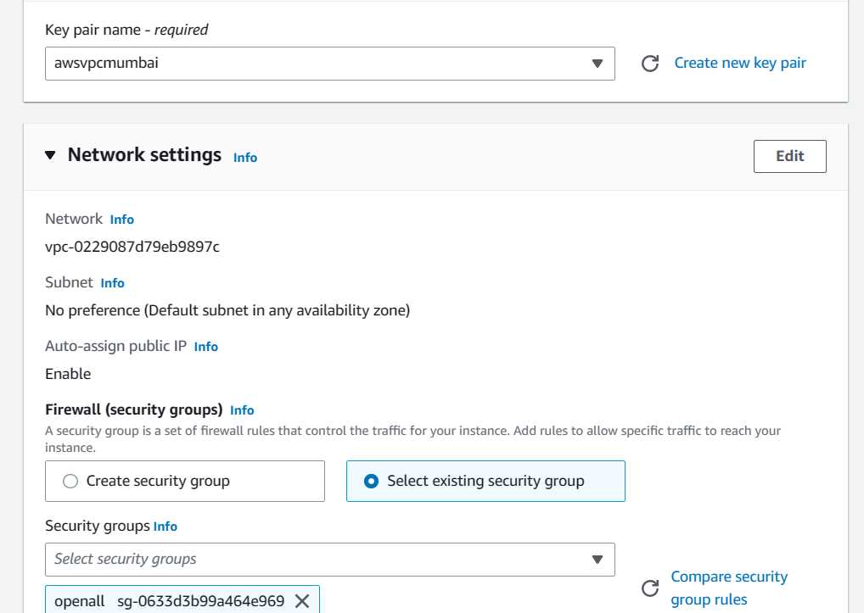

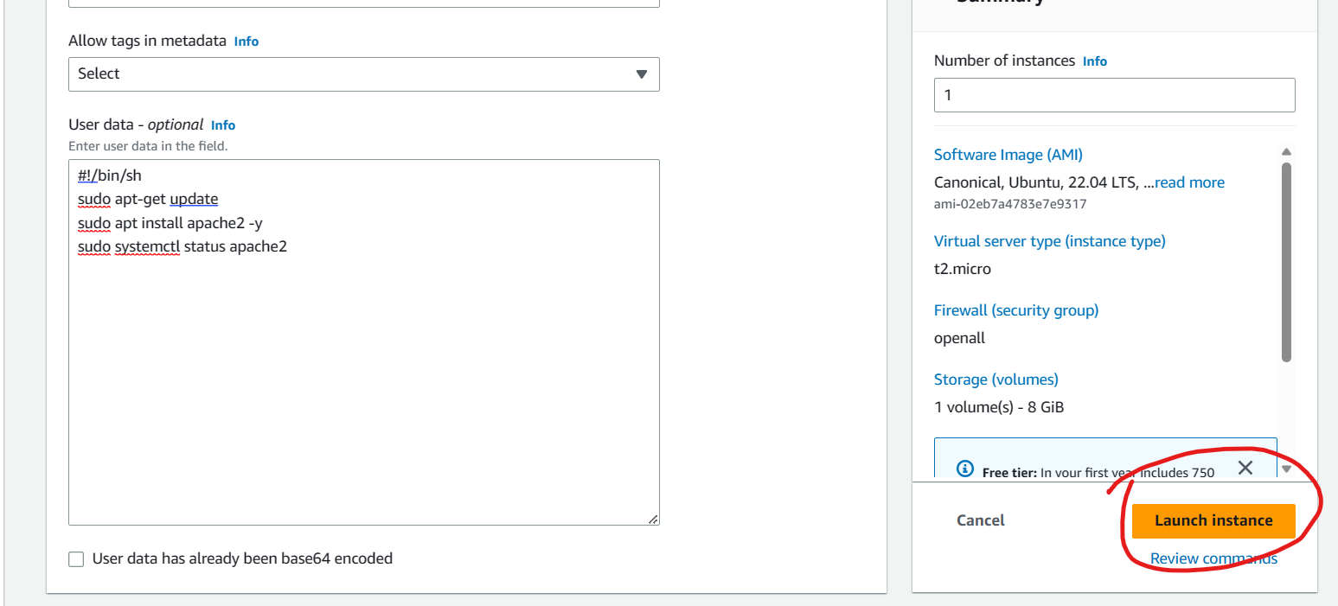

**Take that machine Public ip address and search for browser**

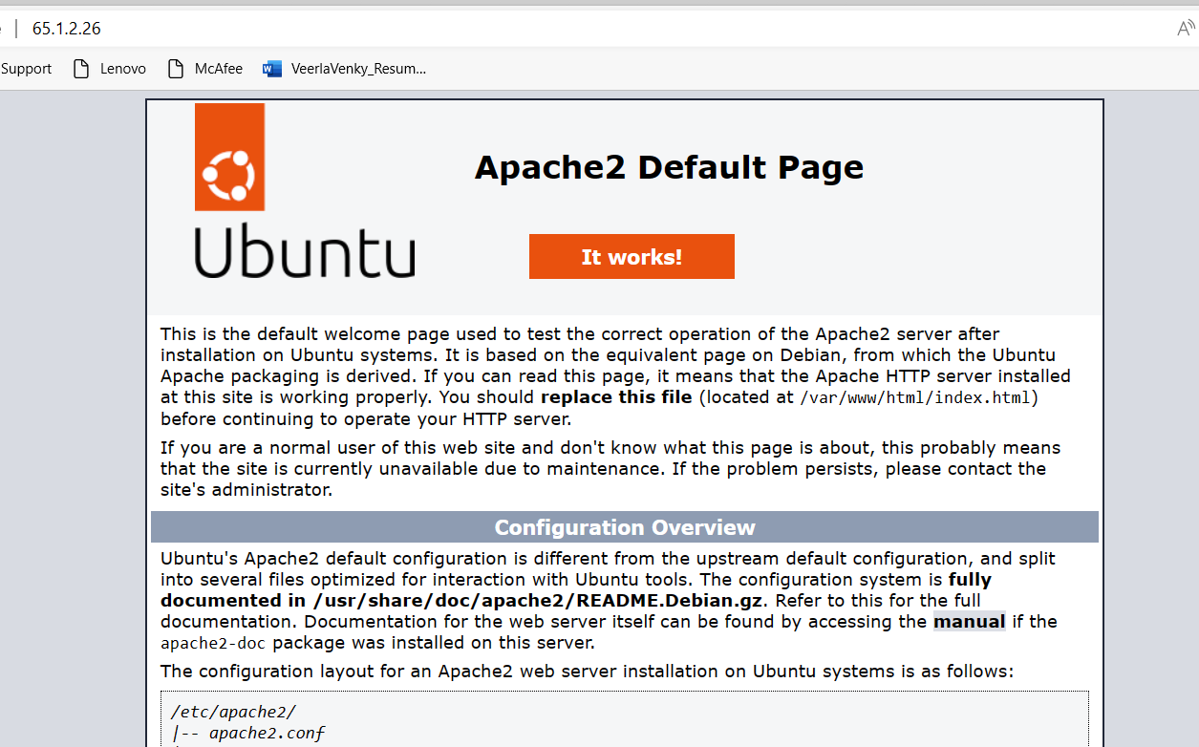

**Centos 7 – Apache2 httpd**

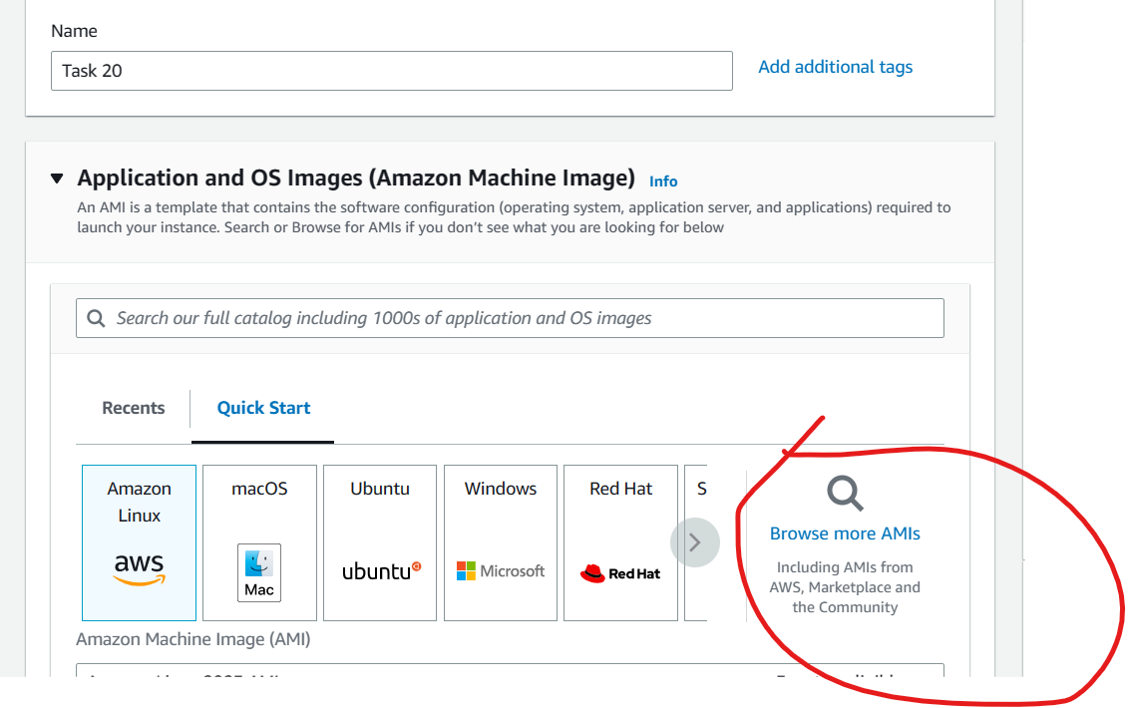

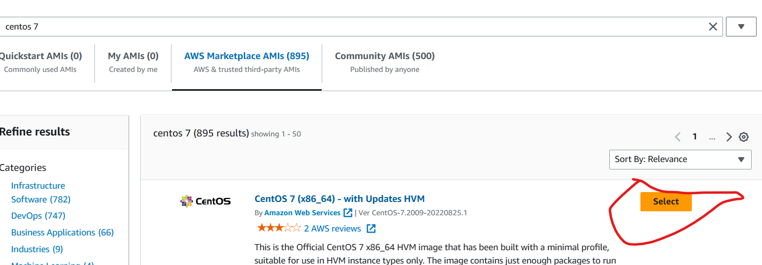

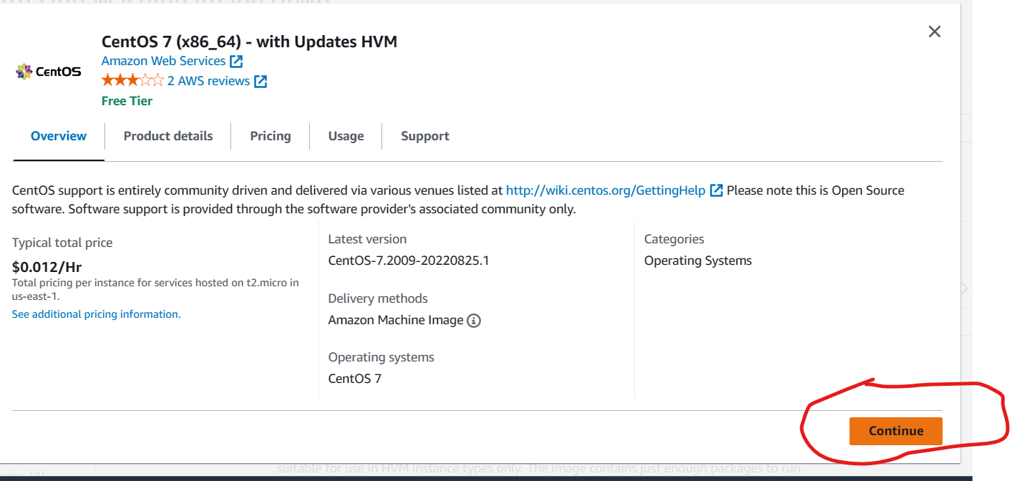

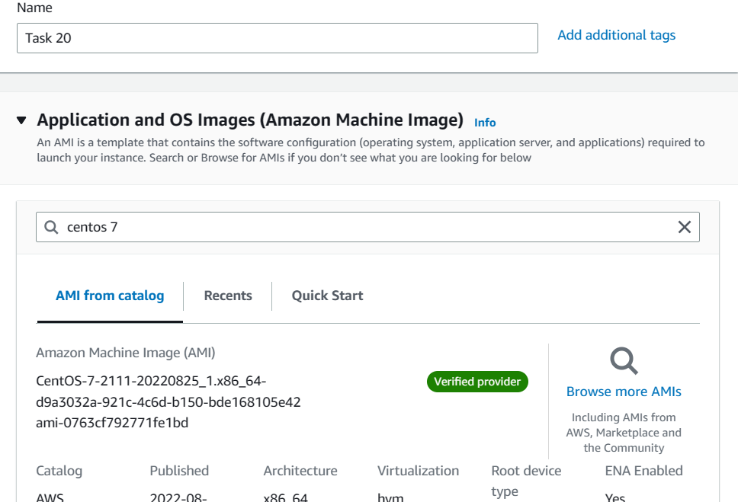

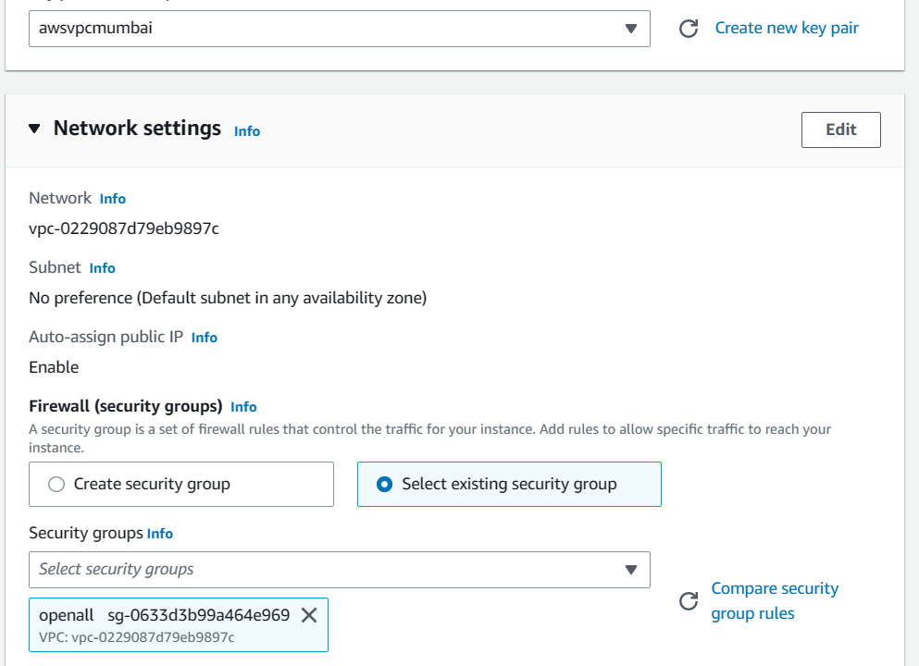

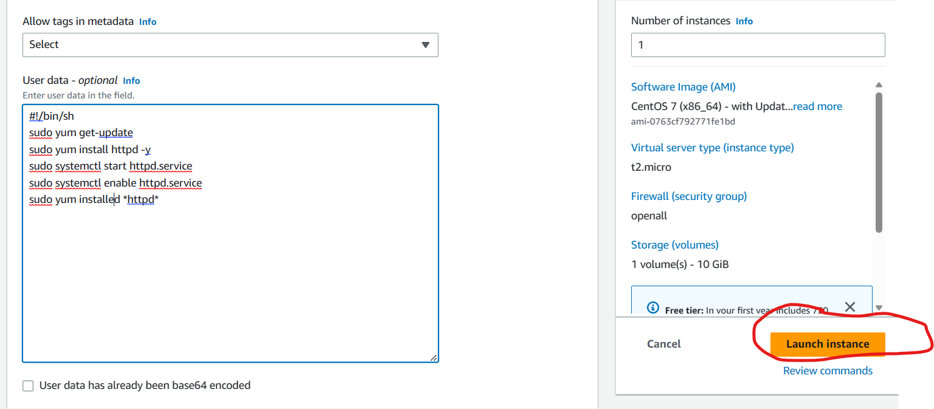

**Take that machine Public ip address and search for browser httpd apache2**

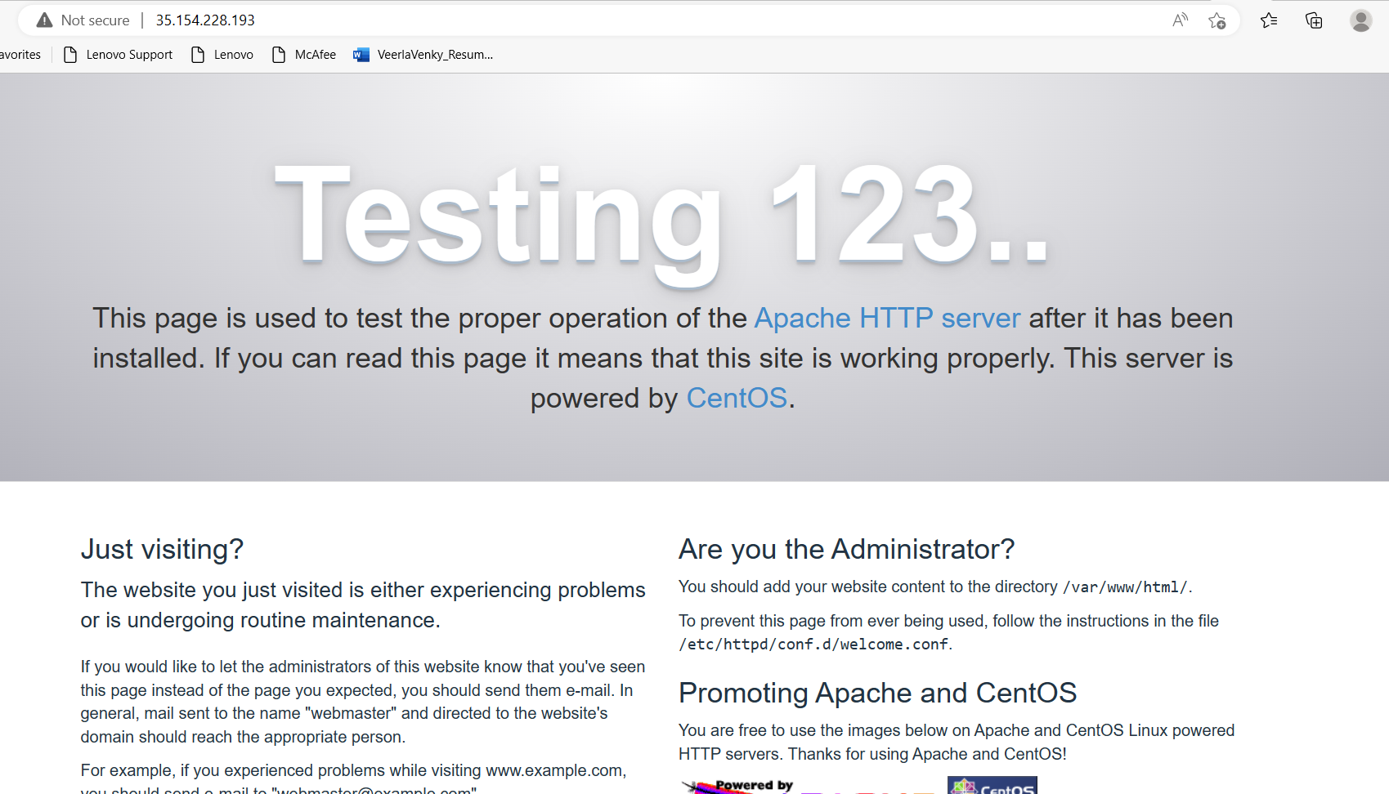

Task 21 : Try to install Docker Ubuntu

**Docker installing on ubuntu --**

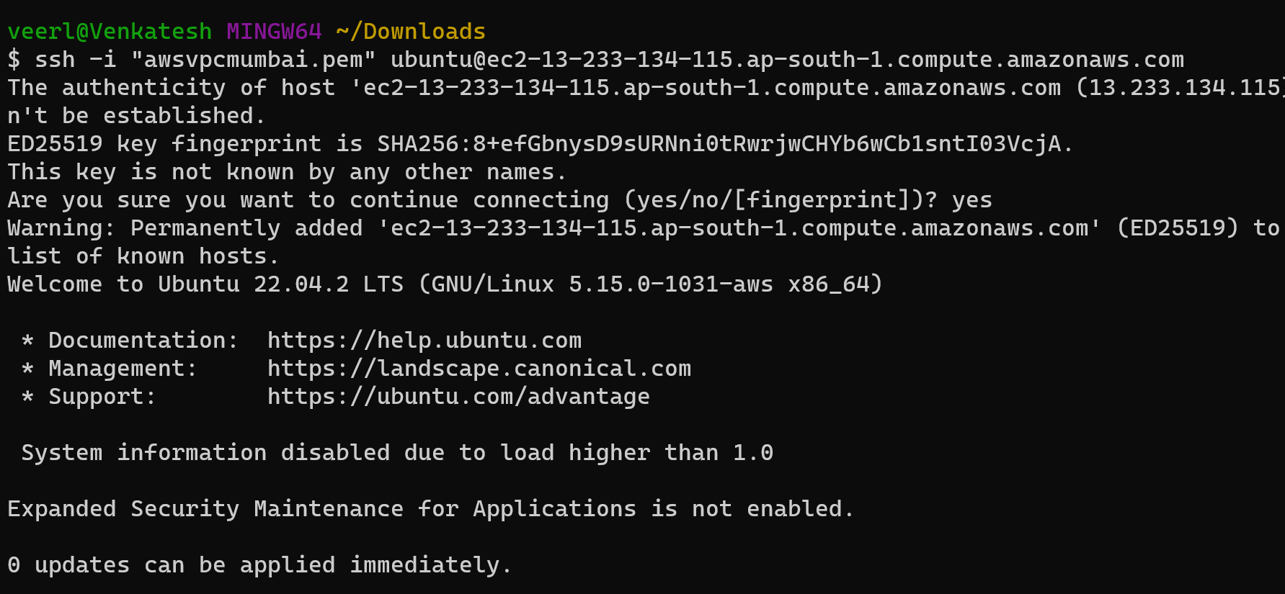

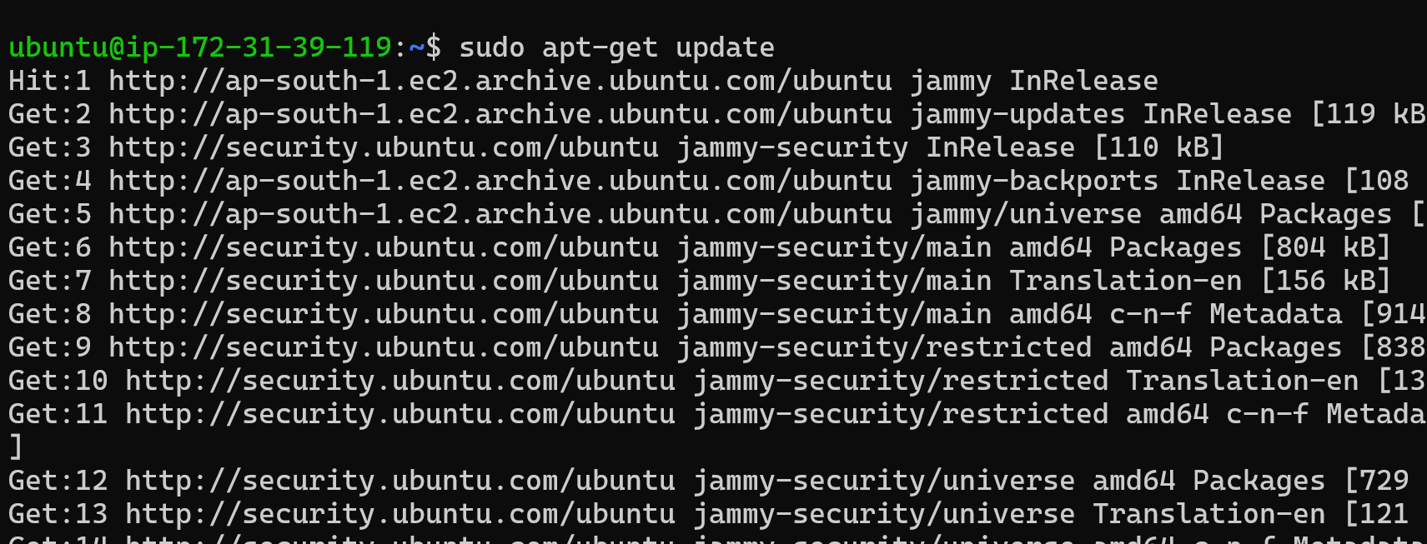

**Search in Google browser Docker script :**

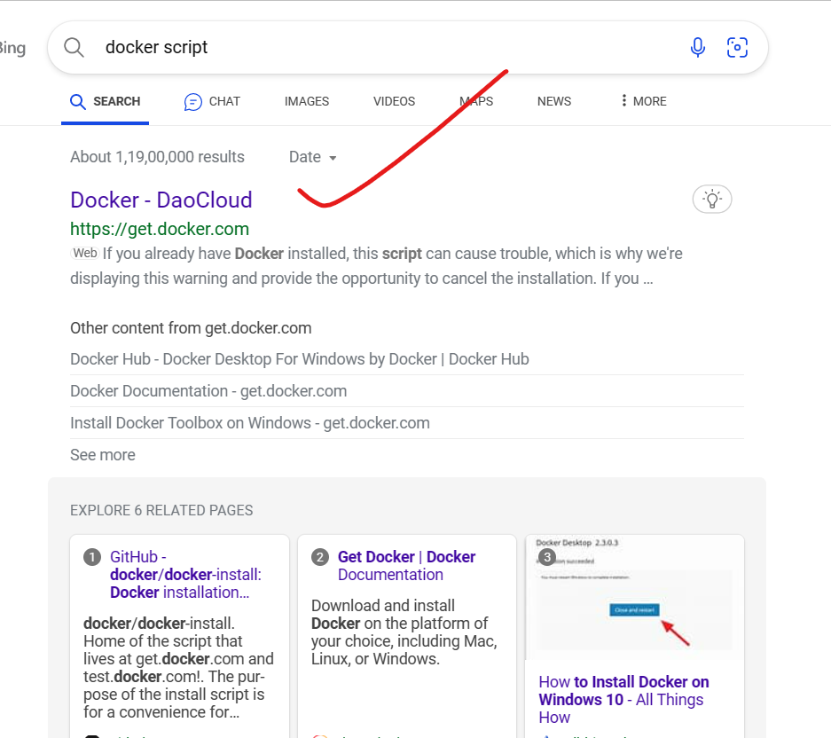

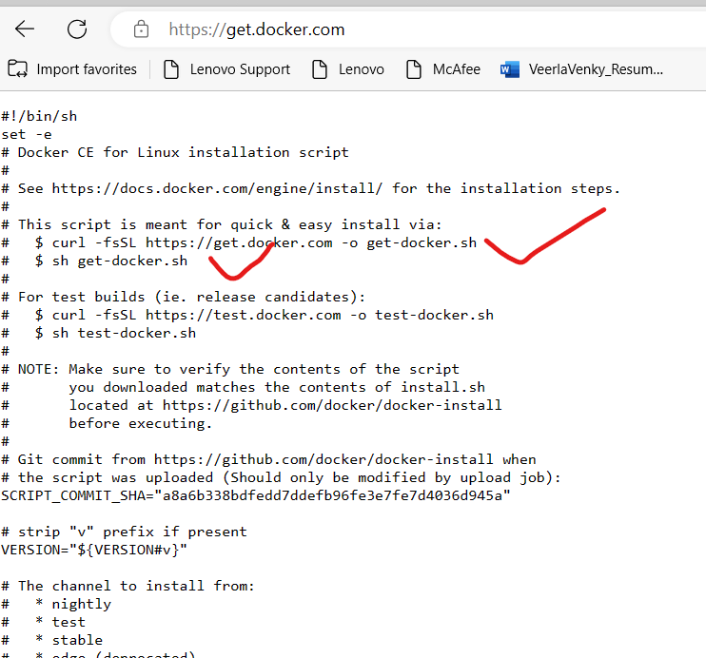

After sudo apt-get update

Executes this commands;

**$ curl -fsSL https://get.docker.com -o get-docker.sh**

**$ sudo sh get-docker.sh**

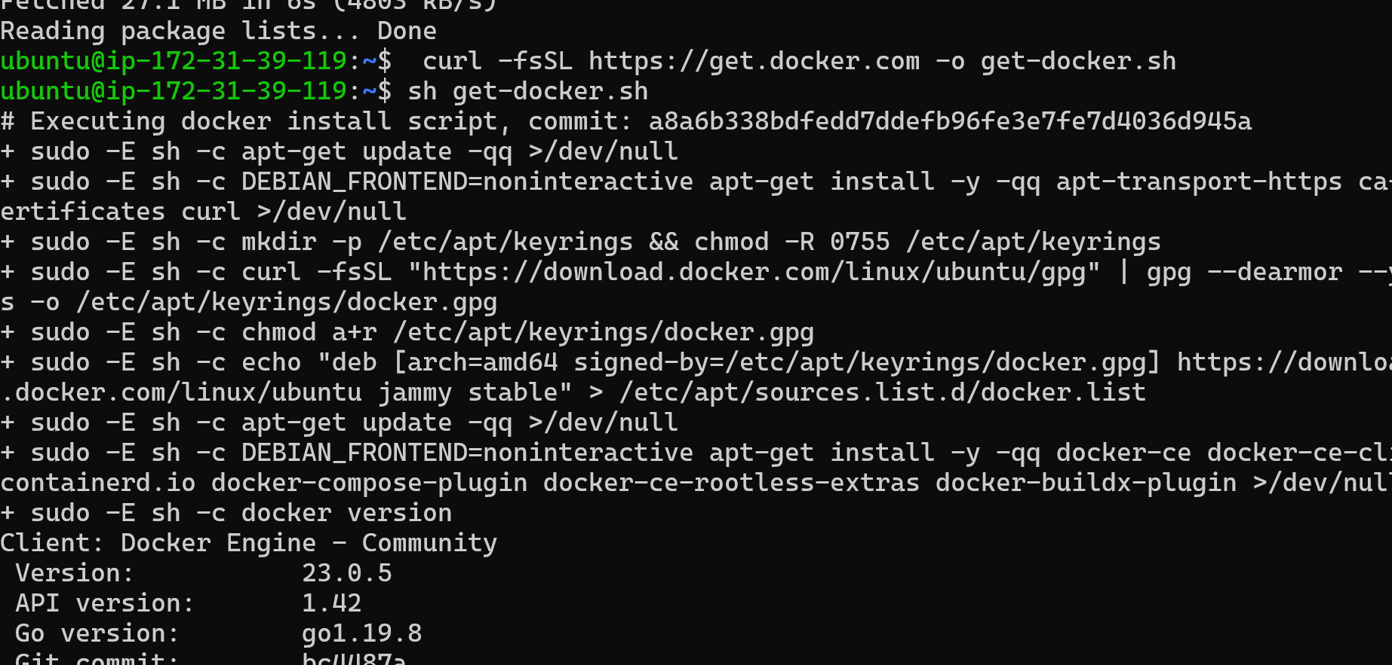

**Add this command sudo usermod -aG docker ubuntu**

**After executes the commands now check once**

**$ docker —version**

**$ docker info**

